**session21_assign_pca.R**

Data Set

2. Perform the below given activities:

|  |  |
| --- | --- |
| **setwd**("C:/Users/prabhjot/Desktop/sv R related/acadgild/assignments/session21") |  |
| **library**(readr)  epi_r <- **read.csv**("C:/Users/prabhjot/Desktop/sv R related/acadgild/assignments/ session21/epi_r.csv") **View**(epi_r) data<-epi_r **View**(data) **head**(data, n=10) **# data sets in package data(package="arules")**  **# Split data dt <- split(data$rating, data$arizona) dt**  **# Loading arules package require(arules) require(arulesViz)**    **# Convert data to transaction level dt2 = as(dt,"transactions") dt2** |

1. Apply PCA to the dataset and show proportion of variance
2. Perform PCA using SVD approach
3. Show the graphs of PCA components

|  |  |
| --- | --- |
| **summary(dt2)** | **ms**  **itemFrequency(dt2, type = "relative") itemFrequencyPlot(dt2,topN = 5) # with support parameters itemFrequency(dt2, type = "relative") itemFrequencyPlot(dt2,support= 0.10)**    **rules = apriori(dt2, parameter=list(support=0.005, confidence=0.8)) rules = apriori(dt2, parameter=list(support=0.005, confidence=0.8, minlen = 3**  **rules = apriori(dt2, parameter=list(support=0.005, confidence=0.8, maxlen = 4**    **inspect(rules[1:10]) # to view first 10 rules**  **ules into data frame**  **rules3 = as(rules, "data.frame") write(rules, "C:/Users/Seshan/Desktop/PCA//rules2.csv", sep=",")**  **# Show only particular product rules inspect( subset( rules, subset = rhs %pin% "0" )[1:10])** |
| **inspect(dt2)**  **# Most Frequent Ite**  **# aggregated data**  **))**  **)) rules summary(rules)**      **#Convert r**      **# Show the top 10 rules options(digits=2) inspect(rules[1:10])** |

|  |
| --- |
| **# Get Summary Information**  **summary(rules) plot(rules) plot(rules, method = "graph", interactive = T)**    **# Sort by Lift rules<-sort(rules, by="lift", decreasing=TRUE)**    **# Sort by Lift rules<-sort(rules, by="lift", decreasing=TRUE)**    **# Remove Unnecessary Rules subset.matrix <- is.subset(rules, rules) subset.matrix[lower.tri(subset.matrix, diag=T)] <- NA redundant <- colSums(subset.matrix, na.rm=T) >= 1 which(redundant) rules.pruned <- rules[!redundant] rules<-rules.pruned rules #Clean Rules rules3$rules=gsub("\\{", "", rules3$rules) rules3$rules=gsub("\\}", "", rules3$rules) rules3$rules=gsub("\"", "", rules3$rules)**    **#Split the rule library(splitstackshape)** |

|  |  |
| --- | --- |
| **Rules4=cSplit(rules3, "rules","=>")** | * **'LHS'**   **c(rules_2))**   * **'RHS'**   **=0.001,conf = 0.8),**  **appearance = list(default="lhs",rhs="0"),**      **"**  **apriori(data=dt, parameter=list(supp=0.001,conf = 0.8),appearance = li**        **plot(support,rules_count,type = "l",main="Number of rules at different suppor** |
| **names(Rules4)[names(Rules4) == 'rules_1'] <**  **Rules5=cSplit(Rules4, "LHS",",") Rules6=subset(Rules5, select= names(Rules6)[names(Rules6) == 'rules_3'] <**    **# What are customers likely to buy before they purchase "Product A" rules<-apriori(data=dt, parameter=list(supp**  **control = list(verbose=F)) rules<-sort(rules, decreasing=TRUE,by="confidence") inspect(rules[1:5])**    **# What are customers likely to buy if they purchased "Product A**  **rules<st(default="rhs",lhs="0"),control = list(verbose=F)) rules<-sort(rules, decreasing=TRUE,by="confidence") inspect(rules[1:5]) rules support<-seq(0.01,0.1,0.01) support rules_count<-c(472,128,46,26,14, 10, 10,8,8,8) rules_count**  **t %",col="darkred",lwd=3)**  **conf<-seq(0.10,1.0,0.10) conf** |

|  |  |
| --- | --- |
| **rules_count<-c(472,231,125,62,15,0,0,0,0,0)** | **_count,type = "l",main="Number of rules at different confidenc** |
| **rules_count**    **plot(conf,rules e %",col="darkred",lwd=3)**  **#rules_ec <- eclat(epi_r, parameter = list(supp = 0.05))**  **#summary(rules_ec)**  **#sorting out the most relevant rules rules<-sort(rules, by="confidence", decreasing=TRUE) inspect(rules[1:5])**  **rules<-sort(rules, by="lift", decreasing=TRUE) inspect(rules[1:5])**    **######################################## library(factoextra)**  **library("factoextra") data1<-na.exclude(data) na.omit(data1) data1.active <- data1[2:100, 2:6] na.exclude(data1.active) View(data1.active) head(data1.active[, 2:5])**    **#Compute PCA in R using prcomp() library(factoextra) res.pca <- prcomp(data1.active, scale = TRUE) res.pca** |

|  |  |
| --- | --- |
| **summary(res.pca)** | **col.ind = "cos2", # Color by the quality of representat**  **gradient.cols = c("#00AFBB", "#E7B800", "#FC4E07"), repel = TRUE # Av**  **fviz_pca_var(res.pca, col.var = "contrib", # Color by contributions to the PC gradient.cols = c("#00AFBB", "#E7B800", "#FC4E07"), repel = TRUE # Avoid**  **fviz_pca_biplot(res.pca, repel = TRUE,col.var = "#2E9FDF", # Variables color col.ind = "#696969" # Individuals color)**    **get_eigenvalue(res.pca)**  **Variables get_pca_var(res.pca)**  **res.var$coord # Coordinates res.var$contrib # Contributions to the PCs res.var$cos2 # Quality of representation**  ## title rating  Lentil, Apple, and Turkey Wrap 2.500  ## 2 Boudin Blanc Terrine with Red Onion Confit 4.375  ## 3 Potato and Fennel Soup Hodge 3.750  ## 4 Mahi-Mahi in Tomato Olive Sauce 5.000  ## 5 Spinach Noodle Casserole 3.125  ## 6 The Best Blts 4.375  ## 7 Ham and Spring Vegetable Salad with Shallot Vinaigrette 4.375  Spicy-Sweet Kumquats 3.750  ## 9 Korean Marinated Beef 4.375  ## 10 Ham Persillade with Mustard Potato Salad and Mashed Peas 3.750  ## calories protein fat sodium X.cakeweek X.wasteless X22.minute.meals  ## 1 426 30 7 559 0 0 0  ## 2 403 18 23 1439 0 0 0  ## 3 165 6 7 165 0 0 0 |
| **fviz_eig(res.pca)**  **fviz_pca_ind(res.pca, ion**  **oid text overlapping)**  **text overlapping)**  **library(factoextra) # Eigenvalues eig.val <- eig.val # Results for res.var <-**        ## 1  ## 8 |

## 4 NA NA NA NA 0 0 0

## 5 547 20 32 452 0 0 0

## 6 948 19 79 1042 0 0 0

## 7 NA NA NA NA 0 0 0

## 8 NA NA NA NA 0 0 0

## 9 170 7 10 1272 0 0 0

## 10 602 23 41 1696 0 0 0

## X3.ingredient.recipes X30.days.of.groceries advance.prep.required

## 1 0 0 0

## 2 0 0 0

## 3 0 0 0

## 4 0 0 0

## 5 0 0 0

## 6 0 0 0

## 7 0 0 0

## 8 0 0 0

## 9 0 0 0

## 10 0 0 0

## alabama alaska alcoholic almond amaretto anchovy anise anniversary

## 1 0 0 0 0 0 0 0 0

## 2 0 0 0 0 0 0 0 0

## 3 0 0 0 0 0 0 0 0

## 4 0 0 0 0 0 0 0 0

## 5 0 0 0 0 0 0 0 0

## 6 0 0 0 0 0 0 0 0

## 7 0 0 0 0 0 0 0 0

## 8 0 0 0 0 0 0 0 0

## 9 0 0 0 0 0 0 0 0

## 10 0 0 0 0 0 0 0 0

## anthony.bourdain aperitif appetizer apple apple.juice apricot arizona

## 1 0 0 0 1 0 0 0

## 2 0 0 0 0 0 0 0

## 3 0 0 0 0 0 0 0

## 4 0 0 0 0 0 0 0

## 5 0 0 0 0 0 0 0

## 6 0 0 0 0 0 0 0

## 7 0 0 0 0 0 0 0

## 8 0 0 0 0 0 0 0

## 9 0 0 0 0 0 0 0

## 10 0 0 0 0 0 0 0

## artichoke arugula asian.pear asparagus aspen atlanta australia avocado

## 1 0 0 0 0 0 0 0 0

## 2 0 0 0 0 0 0 0 0

## 3 0 0 0 0 0 0 0 0

## 4 0 0 0 0 0 0 0 0

## 5 0 0 0 0 0 0 0 0

## 6 0 0 0 0 0 0 0 0

## 7 0 0 0 1 0 0 0 0

## 8 0 0 0 0 0 0 0 0

## 9 0 0 0 0 0 0 0 0

|  |
| --- |
| ## 9 0 0 0 0 0 0  ## 10 0 0 0 0 0 0  *# check data* data  ## title  ## 1 Lentil, Apple, and Turkey Wrap  ## 2 Boudin Blanc Terrine with Red Onion Confit  ## 3 Potato and Fennel Soup Hodge  ## 4 Mahi-Mahi in Tomato Olive Sauce  ## 5 Spinach Noodle Casserole  ## 6 The Best Blts  ## 7 Ham and Spr ing Vegetable Salad with Shallot Vinaigrette  ## 8 Spicy-Sweet Kumquats  ## 9 Korean Marinated Beef  ## 10 Ham Persilla de with Mustard Potato Salad and Mashed Peas  ## 11 Yams Braised with Cream, Rosemary and Nutmeg  ## 12 Spicy Noodle Soup  ## 13 Banana-Cho colate Chip Cake With Peanut Butter Frosting  ## 14  Beef Tenderloin with Garlic and Brandy  ## 15 Peach Mustard  ## 16 Raw Cream of Spinach Soup  ## 17 Sweet Buttermilk Spoon Breads  ## 18 Crisp Braised Pork Shoulder  ## 19 Mozzar ella-Topped Peppers with Tomatoes and Garlic  ## 20 Tuna, Asparagus, and New Potato S alad with Chive Vinaigrette and Fried Capers  ## 21 Asian Pe |

ar and Watercress Salad with Sesame Dressing

## 22

|  |
| --- |
| "Fried" Chicken  ## 23 Fish Fi llets in Parchment with Asparagus and Orange  ## 24  Pancetta and Taleggio Lasagna with Treviso  ## 25  Sea Salt-Roasted Pecans  ## 26  Garlic Baguette Crumbs  ## 27  Cucumber-Basil Egg Salad  ## 28 Dried Pear Crisps  ## 29 Green Bean, Red Onion, and Roast Potato Salad with Rosemary Vinaigrette  ## 30 Apricot-Cherry Shortcakes  ## 31  Asian Steak Topped with Bell Pepper Stir-Fry  ## 32 Moroccan-Style Preserved Lemons  ## 33 Roaste d Sweet-Potato Spears with Bacon Vinaigrette  ## 34  Deviled Ham  ## 35 Fontina Mac with Squash and Sage  ## 36 Aztec Chicken  ## 37  Pastry Twists with Spiced Sugar-Honey Glaze  ## 38 Sauteed Broccoli Rabe  ## 39  Grouper with Tomato and Basil  ## 40 Better-Than-Pita Grill Bread  ## 41  Coconut-Key Lime Sheet Cake  ## 42 Baked Hal ibut with Orzo, Spinach, and Cherry Tomatoes  ## 43 Honey Rye  ## 44 Purple-Potato and Crab Gratin  ## 45  Grilled Beef, JÃ-cama, and Apple Salad  ## 46 |

Pickled Red Onions

## 47

|  |
| --- |
| Spicy Black Beans and Rice  ## 48 Herbed Goat Cheese Spread with Mint  ## 49  Mexican Lime Soup  ## 50  Citrus Salad with Mint Sugar  ## 51  Mexican Chile and Mushroom Soup  ## 52 Peanut Butter-Banana Muffins  ## 53  Braised Chicken With Artichokes and Olives  ## 54 Pancetta Roast Chicken with Walnut Stuffing  ## 55 1977 Coconut Angel Food Cake  ## 56 Collard-and-Prosc iutto Chicken Roulades Over Watercress Salad  ## 57 Veal Burgers Stuffed with Mozzarella Cheese  ## 58 Pumpkin Muffins  ## 59  Orange Balsamic Glaze  ## 60 Roasted Egg plant and Olive Spread with Pita Bread Chips ## 61  Pecan Blue Cheese Crackers  ## 62 Romaine, Grilled Avocado, and Sm oky Corn Salad with Chipotle-Caesar Dressing  ## 63 Southwest Cor n Bread Stuffing with Corn and Green Chilies  ## 64 Coli n Perryâ\200\231s Sorghum and Apple Sticky Pudding  ## 65 Mixed Berry Pavlovas  ## 66  Orange-Almond Cake with Chocolate Icing  ## 67 Scarborough Fair Tofu Burger  ## 68 Italian Vinaigrette  ## 69 White Choc olate Tartlets with Strawberries and Bananas  ## 70  Tomato-Infused Bulgur Pilaf with Fresh Basil  ## 71 Roasted Bu |

tternut Squash, Rosemary, and Garlic Lasagne

## 72

|  |
| --- |
| Grilled Roast Beef and Stilton Sandwich  ## 73 Pear-Ha zelnut Cheesecakes with Pear-Raspberry Sauce  ## 74 Nut Butter  ## 75  Cheese Ravioli with Fresh Tomato Sauce  ## 76  Banana Layer Cake with Cream Cheese Frosting  ## 77 S outh American-Style JÃ-cama and Orange Salad  ## 78 Roasted Acorn Squash and Chestnuts  ## 79 Maple Pumpkin Pots de CrÃ¨me  ## 80 Anadama Rolls with Mixed Seeds  ## 81 Braised Chicken and Rice with Orange, Saffron, Almond, and Pistachio Syrup  ## 82 Horseradish Dill Potato Salad  ## 83 Chicken in Green Pumpkin-Seed Sauce  ## 84  Jeweled Rice  ## 85  Braised Brisket with Bourbon-Peach Glaze  ## 86 Gr illed Pork Chops with Classic Barbecue Sauce  ## 87 Bacon Crackers  ## 88 Roast Chicken With Sorghum and Squash  ## 89 Asparagus with Bacon and Onion  ## 90 Ricotta Omelets  ## 91 Carrot, Snow Pea, and Red Pepper Julienne in Honey Vinaigrette  ## 92  Salmon with Chili-Mango Salsa  ## 93 Turkey and Pinto Bean Chili  ## 94 Cucumber-Yogurt Salad with Mint  ## 95 Lamb Shanks Braised with Anise and Orange  ## 96 |

Parsley Mayo

## 97

|  |
| --- |
| Acini di Pepe Pasta with Garlic and Olives  ## 98 R oast Beef Salad with Cabbage and Horseradish  ## 99 Savoy Cabbage and Arugula Salad  ## 100 Fennel, Beet and Orange Salad with Olives  ## 101 Shrimp Gazpacho  ## 102 Grilled Steak Salad with Beets and Scallions  ## 103 Parsnip and Apple Soup  ## 104 Short Rib Pot Pie  ## 105 Stout Floats  ## 106  Apricot-Pistachio Muffins Baked on the Grill  ## 107 Garlic Bruschetta  ## 108 Asian Noodles with Barbecued Duck Confit  ## 109 Sausage Fennel Stuffing  ## 110 Banan a Split with Curried Chocolate-Coconut Sauce  ## 111 Escarole and Cheese Spoon Bread  ## 112  Honey-Ginger Barbecue Sauce  ## 113 Baked Pea rs with Rosemary, Gorgonzola Cheese and Port  ## 114 Kids' Matzoh Pizza  ## 115 Cranberry, Quince, and Pearl Onion Compote  ## 116 Chocolate-Mint Shamrock Shake  ## 117 Tropical Rum Punch  ## 118 Chickpea S alad Sandwich With Creamy Carrot-Radish Slaw  ## 119  Blackberry-Raspberry Sauce  ## 120  Laddie's Sub-Bourbon  ## 121 |

Red Cabbage and Onions

## 122

|  |
| --- |
| Roast Cod with Potatoes, Onions, and Olives  ## 123 Spicy Tomato Sauce  ## 124 Cod Ca nnelloni with Swiss Chard and Roasted Pepper  ## 125  Swiss Chard with Roasted Pepper  ## 126 Chocolate Almond Butter  ## 127 Pastry Dough  ## 128 Roasted Bell P epper Halves Stuffed with Bulgur and Spinach  ## 129 Spicy Sesame  Noodles with Chopped Peanuts and Thai Basil  ## 130 Potato Gratin with Goat Cheese and Garlic  ## 131 Country Sausage and Sage Dressing  ## 132 Cherry Lime Virgin Rickeys  ## 133 Buttermilk-Spinach Spaetzle  ## 134 Radishes with Burrata  ## 135  Winter Squash SoufflÃ©  ## 136 Blueberry Streusel Cake  ## 137  Low-Fat Chicken Stock  ## 138 Honey Mustard Sauce  ## 139 Rosemary and Lemon Pinto Beans  ## 140 Asian Dipping Sauce  ## 141 Shrimp and Green Onion Pancakes  ## 142 Gnocchi with Tomato, Basil, and Olives  ## 143 Mustard-Ginger Shrimp Canapes  ## 144  Rumbrosia  ## 145  Roasted Root Vegetables  ## 146 |

Thai Vegetables

## 147 Sage-Roasted T

urkey with Caramelized Onions and Sage Gravy

## rating calories protein fat sodium X.cakeweek X.wasteless

## 1 2.500 426 30 7 559 0 0

## 2 4.375 403 18 23 1439 0 0

## 3 3.750 165 6 7 165 0 0

## 4 5.000 NA NA NA NA 0 0

## 5 3.125 547 20 32 452 0 0

## 6 4.375 948 19 79 1042 0 0

## 7 4.375 NA NA NA NA 0 0

## 8 3.750 NA NA NA NA 0 0

## 9 4.375 170 7 10 1272 0 0

## 10 3.750 602 23 41 1696 0 0

## 11 3.750 256 4 5 30 0 0

## 12 4.375 NA NA NA NA 0 0

## 13 4.375 766 12 48 439 0 0

## 14 4.375 174 11 12 176 0 0

## 15 3.125 134 4 3 1394 0 0

## 16 4.375 382 5 31 977 0 0

## 17 1.875 146 4 5 160 0 0

## 18 4.375 890 59 68 1027 0 0

## 19 5.000 107 5 7 344 0 0

## 20 5.000 421 10 33 383 0 0

## 21 4.375 345 11 19 423 0 0

## 22 3.750 NA NA NA NA 0 0

## 23 3.750 NA NA NA NA 0 0

## 24 3.750 NA NA NA NA 0 0

## 25 3.750 279 3 30 206 0 0

## 26 0.000 95 1 7 103 0 0

## 27 3.750 215 6 20 250 0 0

## 28 2.500 14 0 0 0 0 0

## 29 4.375 351 6 19 79 0 0

## 30 4.375 311 5 5 226 0 0

## 31 4.375 NA NA NA NA 0 0

## 32 5.000 NA NA NA NA 0 0

## 33 4.375 376 7 18 604 0 0

## 34 3.125 185 10 13 765 0 0

## 35 5.000 NA NA NA NA 0 0

## 36 3.750 625 39 44 1248 0 0

## 37 0.000 NA NA NA NA 0 0

## 38 4.375 107 4 10 329 0 0

## 39 4.375 336 44 16 413 0 0

## 40 2.500 145 3 6 208 0 0

## 41 4.375 483 5 35 100 0 0

## 42 4.375 634 44 31 181 0 0

## 43 0.000 NA NA NA NA 0 0

## 44 3.750 NA NA NA NA 0 0

## 45 4.375 NA NA NA NA 0 0

## 46 4.375 90 2 0 881 0 0

## 47 3.750 202 19 8 815 0 0

##

## 101 0 0 0 0 0 0 0 0

## 102 0 0 0 0 1 0 0 0

## 103 0 0 0 0 0 0 0 0

## 104 0 0 0 0 1 0 0 0

## 105 0 1 0 0 0 0 0 0

## 106 0 0 0 0 0 0 0 0

## 107 0 0 0 0 0 0 0 0

## 108 0 0 0 0 0 0 0 0

## 109 0 0 0 0 0 0 0 0

## 110 0 1 0 0 0 0 0 0

## 111 0 0 0 0 0 0 0 0

## 112 0 0 0 0 0 0 0 0

## 113 0 1 0 0 0 0 0 0

## 114 0 0 0 0 0 0 0 0

## 115 0 0 0 0 0 0 0 0

## 116 0 0 0 0 0 0 0 0

## 117 0 0 0 0 0 0 0 0

## 118 0 0 0 0 0 0 0 0

## 119 0 1 0 0 0 0 0 0

## 120 0 0 0 0 0 0 0 0

## 121 0 0 0 0 0 0 0 0

## 122 0 0 0 0 0 0 0 0

## 123 0 0 0 0 0 0 0 0

## 124 0 0 0 0 0 0 0 0

## 125 0 0 0 0 0 0 0 0

## 126 0 0 0 0 0 0 0 0

## 127 0 0 0 0 0 0 0 0

## 128 0 0 0 0 0 0 0 0

## 129 0 0 0 0 1 0 0 0

## 130 0 0 0 0 0 0 0 0

## 131 0 0 0 0 0 0 0 0

## 132 0 0 0 0 0 0 0 0

## 133 0 0 0 0 0 0 0 0

## 134 0 0 0 0 0 0 0 0

## 135 0 0 0 0 0 0 0 0

## 136 0 1 0 0 0 0 0 0

## 137 0 0 0 0 0 0 0 0

## 138 0 0 0 0 0 0 0 0

## 139 0 0 0 0 0 0 0 0

## 140 0 0 0 0 0 0 0 0

## 141 0 0 0 0 1 0 0 0

## 142 0 0 0 0 1 0 0 0

## 143 0 0 0 0 0 0 0 0

## 144 0 0 0 0 0 0 0 0

## 145 0 0 0 0 0 0 0 0

## 146 0 0 0 0 0 0 0 0

## 147 0 0 0 0 1 0 0 0

## dorie.greenspan double.boiler dried.fruit drink drinks duck easter ## 1 0 0 0 0 0 0 0

## 2 0 0 1 0 0 0 0

## 3 0 0 0 0 0 0 0

## 4 0 0 0 0 0 0 0

## 5 0 0 0 0 0 0 0

## 6 0 0 0 0 0 0 0

## 7 0 0 0 0 0 0 1

## 8 0 0 0 0 0 0 0

## 9 0 0 0 0 0 0 0

## 10 0 0 0 0 0 0 0

## 11 0 0 0 0 0 0 0

## 12 0 0 0 0 0 0 0

## 13 0 0 0 0 0 0 0

## 14 0 0 0 0 0 0 0

## 15 0 0 0 0 0 0 0

## 16 0 0 0 0 0 0 0

## 17 0 0 0 0 0 0 0

## 18 0 0 0 0 0 0 0

## 19 0 0 0 0 0 0 0

## 20 0 0 0 0 0 0 0 ## 21 0 0 0 0 0 0 0

## 116 0 0

## 117 0 0

## 118 0 0

## 119 0 0

## 120 0 0

## 121 0 0

## 122 0 0

## 123 0 0

## 124 0 0

## 125 0 0

## 126 0 0

## 127 0 0

## 128 0 0

## 129 0 0

## 130 0 0

## 131 0 0

## 132 0 0

## 133 0 0

## 134 0 0

## 135 0 0

## 136 0 0

## 137 0 0

## 138 0 0

## 139 0 0

## 140 0 0

## 141 0 0

## 142 0 0

## 143 0 0

## 144 0 0

|  |
| --- |
| ## 145 0 0  ## 146 0 0  ## 147 0 1  ## [ reached getOption("max.print") -- omitted 19905 rows ] **head**(data, n=10)  ## title rating  ## 1 Lentil, Apple, and Turkey Wrap 2.500  ## 2 Boudin Blanc Terrine with Red Onion Confit 4.375  ## 3 Potato and Fennel Soup Hodge 3.750  ## 4 Mahi-Mahi in Tomato Olive Sauce 5.000  ## 5 Spinach Noodle Casserole 3.125  ## 6 The Best Blts 4.375  ## 7 Ham and Spring Vegetable Salad with Shallot Vinaigrette 4.375  ## 8 Spicy-Sweet Kumquats 3.750  ## 9 Korean Marinated Beef 4.375  ## 10 Ham Persillade with Mustard Potato Salad and Mashed Peas 3.750  ## calories protein fat sodium X.cakeweek X.wasteless X22.minute.meals  ## 1 426 30 7 559 0 0 0  ## 2 403 18 23 1439 0 0 0  ## 3 165 6 7 165 0 0 0  ## 4 NA NA NA NA 0 0 0  ## 5 547 20 32 452 0 0 0  ## 6 948 19 79 1042 0 0 0  ## 7 NA NA NA NA 0 0 0  ## 8 NA NA NA NA 0 0 0  ## 9 170 7 10 1272 0 0 0  ## 10 602 23 41 1696 0 0 0  ## X3.ingredient.recipes X30.days.of.groceries advance.prep.required |

## [12673] 3.125 5.000 5.000 4.375 5.000 4.375 4.375 4.375 3.750 0.000 0.000

## [12541] 4.375 4.375 3.125 4.375 3.750 5.000 4.375 4.375 4.375 3.750 4.375

## [12552] 0.000 4.375 5.000 3.750 4.375 4.375 0.000 4.375 3.125 3.750 5.000

## [12563] 3.750 3.750 4.

375 4.375 5.000 2.500 3.125 5.000 3.750 3.125 4.375

## [12574] 4.375 3.750 5.000 5.000 3.750 2.500 4.375 5.000 4.375 3.125 4.375

## [12585] 3.750 4.375 5.000 4.375 4.375 4.375 2.500 3.750 3.125 4.375 5.000

## [12596] 3.125 3.750 0.000 4.375 3.750 4.375 0.0

00 4.375 3.750 0.000 5.000

## [12607] 4.375 4.375 1.250 4.375 0.000 3.750 3.750 4.375 0.000 0.000 0.000

## [12618] 4.375 0.000 4.375 3.750 4.375 4.375 3.750 5.000 5.000 4.375 3.750

## [12629] 3.750 3.750 3.750 4.375 3.750 0.000 3.750 3.750 0.000 4.375 4.37

5

## [12640] 3.750 1.875 3.750 4.375 5.000 3.750 3.750 3.125 4.375 2.500 4.375

## [12651] 3.750 3.750 4.375 3.125 3.750 4.375 3.750 4.375 2.500 4.375 4.375

## [12662] 4.375 4.375 3.750 3.750 5.000 3.750 4.375 2.500 0.000 0.000 4.375



## [12717] 3.750 1.250 4.375 4.375 5.000 4.375 3.750 4.375 3.750 3.750 5.000

## [12728] 4.375 3.125 5.000 5.000 5.000 1.875 3.750 3.750 3.750 0.000 4.375

## [12739] 4.375 4.375 3.750 3.750 3.125 1.250 4.375 4.375 3.750 4.375 3.

750

## [12750] 3.750 4.375 3.750 3.750 4.375 4.375 4.375 2.500 3.125 4.375 4.375

## [12761] 5.000 4.375 4.375 5.000 0.000 5.000 4.375 3.750 4.375 4.375 3.125

## [12772] 3.750 3.125 3.750 3.750 4.375 0.000 5.000 5.000 3.750 4.375 1.250

## [12783] 4.375 4.37

5 3.750 3.750 4.375 4.375 3.750 4.375 3.125 4.375 5.000

## [12794] 5.000 3.125 3.750 3.750 3.750 5.000 4.375 5.000 5.000 5.000 3.750

## [12805] 2.500 5.000 0.000 3.125 3.750 4.375 4.375 4.375 5.000 4.375 4.375

## [12816] 3.750 5.000 4.375 0.000 5.000 3.750

5.000 4.375 4.375 1.250 4.375

## [12827] 4.375 4.375 5.000 4.375 3.750 4.375 4.375 5.000 4.375 5.000 3.750

## [12838] 2.500 3.750 4.375 0.000 5.000 4.375 4.375 3.750 3.750 4.375 3.750

## [12849] 4.375 4.375 4.375 3.750 0.000 0.000 4.375 3.750 3.750 3.750

5.000

## [12860] 3.750 4.375 4.375 0.000 4.375 0.000 4.375 0.000 4.375 0.000 3.125

## [12871] 4.375 5.000 4.375 3.750 5.000 4.375 3.125 3.750 2.500 4.375 5.000

## [12882] 3.750 3.750 5.000 0.000 1.250 3.750 4.375 3.750 4.375 3.750 5.000

## [12893] 3.750 4.375 3.125 3.750 4.375 3.750 4.375 4.375 4.375 3.750 0.000

## [12904] 4.375 3.750 4.375 4.375 4.375 3.750 5.000 3.750 4.375 3.125 3.125

## [12915] 0.000 5.000 4.375 0.000 3.750 4.375 3.750 4.375 4.375 0.000 3.750

## [12926] 3.125 3.125 3.750 4.375 5.000 0.0

00 4.375 3.750 0.000 5.000 4.375

## [12937] 2.500 4.375 3.750 4.375 4.375 4.375 0.000 4.375 3.750 4.375 3.750

## [12948] 4.375 3.750 5.000 4.375 4.375 3.125 4.375 4.375 0.000 4.375 3.750

## [12959] 0.000 3.750 4.375 3.125 3.750 0.000 4.375 5.000 3.125 5.00

0 3.750

## [12970] 3.125 3.125 5.000 4.375 4.375 0.000 3.125 0.000 3.750 3.750 4.375

## [12981] 5.000 4.375 3.750 4.375 5.000 4.375 3.125 3.750 5.000 3.750 0.000

## [12992] 0.000 5.000 5.000 4.375 4.375 4.375 0.000 5.000 3.750 0.000 3.750

## [13003] 0.000

0.000 4.375 4.375 4.375 4.375 3.750 4.375 0.000 5.000 4.375

## [13014] 4.375 4.375 3.750 4.375 4.375 0.000 4.375 4.375 0.000 4.375 3.750

## [13025] 4.375 3.125 0.000 4.375 3.750 3.750 0.000 5.000 3.750 0.000 5.000

## [13036] 5.000 4.375 3.125 3.125 4.375

3.125 4.375 5.000 4.375 3.750 3.750

## [13047] 5.000 0.000 3.750 3.750 5.000 4.375 4.375 3.750 3.750 4.375 0.000

## [13058] 3.750 3.750 3.125 5.000 3.125 4.375 4.375 3.750 3.750 3.750 3.750

## [13069] 4.375 3.750 4.375 3.125 0.000 5.000 0.000 4.375 4.375 0

.000 4.375

## [13080] 0.000 3.750 2.500 4.375 4.375 4.375 0.000 5.000 3.125 2.500 4.375

## [13091] 3.125 3.750 3.750 0.000 4.375 3.750 0.000 5.000 3.750 3.750 4.375

## [13102] 4.375 0.000 3.125 3.125 5.000 3.750 4.375 4.375 3.750 4.375 3.750

## [13113] 3.750 3.750 3.750 4.375 4.375 4.375 4.375 5.000 3.750 3.750 3.750

## [13234] 4.375 4.375 3.750 3.750 3.750 3.125 5.000 4.375 4.375 0.000 0.000

## [13124] 3.750 0.000 3.750 4.375 0.000 3.750 4.375 4.375 4.375 3.750 4.375

## [13135] 0.000 4.375 0.000 3.750 5.000 4.375 3.125 4.375 0.000 4.375 4.375

## [13146] 4.375 4.375 4.375 4.375 4.37

5 3.750 5.000 4.375 3.750 3.750 3.750

## [13157] 5.000 5.000 0.000 3.750 4.375 5.000 4.375 4.375 3.125 4.375 3.125

## [13168] 4.375 5.000 3.750 5.000 5.000 4.375 5.000 5.000 3.125 4.375 4.375

## [13179] 2.500 0.000 2.500 4.375 4.375 4.375 4.375 4.375 4.375

4.375 4.375

## [13190] 3.750 3.750 2.500 4.375 4.375 3.750 3.125 4.375 0.000 4.375 1.875

## [13201] 4.375 4.375 4.375 5.000 3.750 4.375 4.375 4.375 3.125 5.000 3.750

## [13212] 4.375 3.750 0.000 4.375 4.375 5.000 0.000 0.000 4.375 5.000 0.000

## [13223] 4

.375 0.000 4.375 3.125 0.000 3.750 3.750 4.375 2.500 4.375 4.375

## [13245] 3.750 3.125 4.375 4.375 4.375 3.750 3.125 3.125 0.000 4.375 4.375

## [13256] 4.375 0.000 3.125 3.750 0.000 5.000 3.750 4.375 3.750 4.375 1.250

## [13267] 0.000 5.000 4.375 4.375 3.750 4.375 2.500 3.125 3.750 4.375 4.375

|  |
| --- |
| ##  ## $`1`  ## [1] 3.750 3.750 4.375 4.375 3.750 4.375 4.375 5.000  *# Loading arules package* **require**(arules)  ## Loading required package: arules ## Loading required package: Matrix  ##  ## Attaching package: 'arules'  ## The following objects are masked from 'package:base':  ##  ## abbreviate, write **require**(arulesViz)  ## Loading required package: arulesViz  ## Loading required package: grid  *# Convert data to transaction level* dt2 = **as**(dt,"transactions")  ## Warning in asMethod(object): removing duplicated items in transactions dt2  ## transactions in sparse format with  ## 2 transactions (rows) and  ## 8 items (columns) **summary**(dt2) |

## [13278] 5.000 3.750 5.000 4.375 1.875 4.375 5.000 4.375 3.125 3.750 0.000

## [13289] 3.750 4.375 4.375 3.125 5.000 4.375 4.375 3.125 3.1

25 4.375 4.375

## [19900] 4.375 4.375 3.125 4.375 3.750 4.375 3.750 4.375 5.000 4.375 3.750

## [19911] 4.375 4.375 0.000

4.375 3.125 3.750 4.375 5.000 3.750 4.375 4.375

## [19922] 4.375 4.375 4.375 3.125 4.375 3.750 3.125 4.375 4.375 4.375 0.000

## [19933] 0.000 3.750 3.750 3.750 3.125 5.000 0.000 4.375 4.375 1.250 0.000

## [19944] 0.000 5.000 4.375 4.375 3.750 3.125 3.750

3.750 3.750 3.750 3.750

## [19955] 4.375 4.375 5.000 0.000 0.000 4.375 0.000 3.750 4.375 4.375 3.750

## [19966] 3.750 3.125 4.375 0.000 3.750 3.750 3.125 4.375 4.375 4.375 0.000

## [19977] 5.000 4.375 4.375 3.750 5.000 4.375 3.750 4.375 4.375 3.750 3.750

## [19988] 3.750 0.000 4.375 5.000 5.000 0.000 4.375 2.500 2.500 3.750 4.375

## [19999] 0.000 4.375 0.000 3.750 5.000 5.000 3.750 3.750 4.375 4.375 3.125

## [20010] 4.375 5.000 0.000 3.750 5.000 4.375 3.125 4.375 4.375 5.000 4.375

## [20021] 3.750 3.750 3.

750 5.000 4.375 5.000 4.375 3.750 5.000 0.000 3.125

## [20032] 3.125 4.375 2.500 2.500 5.000 3.750 3.750 3.750 3.125 4.375 4.375

## [20043] 4.375 4.375

|  |
| --- |
| ## transactions as itemMatrix in sparse format with  ## 2 rows (elements/itemsets/transactions) and  ## 8 columns (items) and a density of 0.6875 ##  ## most frequent items:  ## 3.75 4.375 5 0 1.25 (Other) ## 2 2 2 1 1 3 ##  ## element (itemset/transaction) length distribution: ## sizes  ## 3 8  ## 1 1  ##  ## Min. 1st Qu. Median Mean 3rd Qu. Max. ## 3.00 4.25 5.50 5.50 6.75 8.00 ##  ## includes extended item information - examples:  ## labels  ## 1 0  ## 2 1.25  ## 3 1.875  ##  ## includes extended transaction information - examples:  ## transactionID  ## 1 0 ## 2 1 **inspect**(dt2)  ## items transactionID ## [1] {0,1.25,1.875,2.5,3.125,3.75,4.375,5} 0  ## [2] {3.75,4.375,5} 1  *# Most Frequent Items* **itemFrequency**(dt2, type = "relative")  ## 0 1.25 1.875 2.5 3.125 3.75 4.375 5 ## 0.5 0.5 0.5 0.5 0.5 1.0 1.0 1.0 **itemFrequencyPlot**(dt2,topN = 5) |

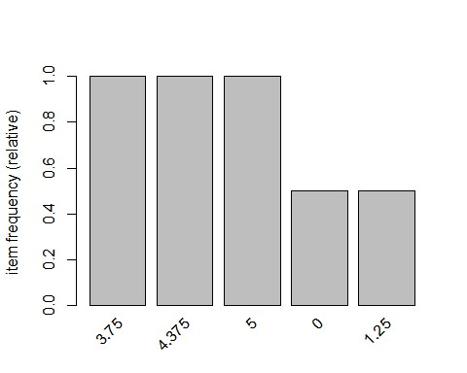

|  |  |
| --- | --- |
| *# with support parameters* | "relative")  ## 0 1.25 1.875 2.5 3.125 3.75 4.375 5    support= 0.10) |
| **itemFrequency**(dt2, type =  ## 0.5 0.5 0.5 0.5 0.5 1.0 1.0 1.0 **itemFrequencyPlot**(dt2, |

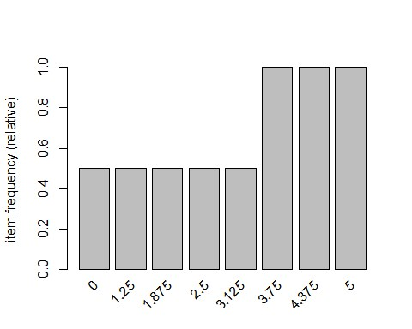

|  |  |
| --- | --- |
| *# aggregated data* | dt2, parameter=**list**(support=0.005, confidence=0.8))    ## confidence minval smax arem aval originalSupport maxtime support minlen  ALSE TRUE 5 0.005 1        ## filter tree heap memopt load sort verbose  ## 0.1 TRUE TRUE FALSE TRUE 2 TRUE  ## Absolute minimum support count: 0  ## set item appearances ...[0 item(s)] done [0.00s].  ## set transactions ...[8 item(s), 2 transaction(s)] done [0.00s].  ## sorting and recoding items ... [8 item(s)] done [0.00s].  ## creating transaction tree ... done [0.00s].  1 2 3 4 5 6 7 8 done [0.00s].  ## writing ... [984 rule(s)] done [0.00s].  ## creating S4 object ... done [0.00s].  dt2, parameter=**list**(support=0.005, confidence=0.8, minlen = 3 |
| rules = **apriori**(  ## Apriori  ##  ## Parameter specification:  ## 0.8 0.1 1 none F  ## maxlen target ext  ## 10 rules FALSE  ##  ## Algorithmic control:  ##  ##  ## checking subsets of size  rules = **apriori**(  )) |

|  |
| --- |
| ## Apriori  ##  ## Parameter specification:  ## confidence minval smax arem aval originalSupport maxtime support minlen ## 0.8 0.1 1 none FALSE TRUE 5 0.005 3  ## maxlen target ext  ## 10 rules FALSE  ##  ## Algorithmic control:  ## filter tree heap memopt load sort verbose ## 0.1 TRUE TRUE FALSE TRUE 2 TRUE ##  ## Absolute minimum support count: 0 ##  ## set item appearances ...[0 item(s)] done [0.00s].  ## set transactions ...[8 item(s), 2 transaction(s)] done [0.00s].  ## sorting and recoding items ... [8 item(s)] done [0.00s].  ## creating transaction tree ... done [0.00s].  ## checking subsets of size 1 2 3 4 5 6 7 8 done [0.00s].  ## writing ... [940 rule(s)] done [0.00s].  ## creating S4 object ... done [0.00s].  rules = **apriori**(dt2, parameter=**list**(support=0.005, confidence=0.8, maxlen = 4 ))  ## Apriori  ##  ## Parameter specification:  ## confidence minval smax arem aval originalSupport maxtime support minlen ## 0.8 0.1 1 none FALSE TRUE 5 0.005 1  ## maxlen target ext  ## 4 rules FALSE  ##  ## Algorithmic control:  ## filter tree heap memopt load sort verbose  ## 0.1 TRUE TRUE FALSE TRUE 2 TRUE ##  ## Absolute minimum support count: 0 ##  ## set item appearances ...[0 item(s)] done [0.00s].  ## set transactions ...[8 item(s), 2 transaction(s)] done [0.00s].  ## sorting and recoding items ... [8 item(s)] done [0.00s].  ## creating transaction tree ... done [0.00s].  ## checking subsets of size 1 2 3 4  ## Warning in apriori(dt2, parameter = list(support = 0.005, confidence = ## 0.8, : Mining stopped (maxlen reached). Only patterns up to a length of 4 ## returned! |

|  |
| --- |
| ## done [0.00s].  ## writing ... [472 rule(s)] done [0.00s]. ## creating S4 object ... done [0.00s].  rules  ## set of 472 rules **summary**(rules)  ## set of 472 rules  ##  ## rule length distribution (lhs + rhs):sizes  ## 1 2 3 4  ## 3 41 153 275  ##  ## Min. 1st Qu. Median Mean 3rd Qu. Max. ## 1.000 3.000 4.000 3.483 4.000 4.000 ##  ## summary of quality measures:  ## support confidence lift count  ## Min. :0.5000 Min. :1 Min. :1.000 Min. :1.000  ## 1st Qu.:0.5000 1st Qu.:1 1st Qu.:1.000 1st Qu.:1.000  ## Median :0.5000 Median :1 Median :2.000 Median :1.000  ## Mean :0.5127 Mean :1 Mean :1.593 Mean :1.025  ## 3rd Qu.:0.5000 3rd Qu.:1 3rd Qu.:2.000 3rd Qu.:1.000 ## Max. :1.0000 Max. :1 Max. :2.000 Max. :2.000 ##  ## mining info:  ## data ntransactions support confidence ## dt2 2 0.005 0.8 **inspect**(rules[1**:**10]) *# to view first 10 rules*  ## lhs rhs support confidence lift count  ## [1] {} => {3.75} 1.0 1 1 2  ## [2] {} => {4.375} 1.0 1 1 2  ## [3] {} => {5} 1.0 1 1 2  ## [4] {0} => {1.25} 0.5 1 2 1  ## [5] {1.25} => {0} 0.5 1 2 1  ## [6] {0} => {1.875} 0.5 1 2 1  ## [7] {1.875} => {0} 0.5 1 2 1  ## [8] {0} => {2.5} 0.5 1 2 1  ## [9] {2.5} => {0} 0.5 1 2 1  ## [10] {0} => {3.125} 0.5 1 2 1  *#Convert rules into data frame* rules3 = **as**(rules, "data.frame")  **write**(rules, "C:/Users/Seshan/Desktop/PCA//rules2.csv", sep=",") |

|  |  |
| --- | --- |
| *# Show only particular product rules* | **%pin%** "0" )[1**:**10])  unt          {0} 0.5 1 2 1        1 2 1      2           1. 2 1          1. 1             1st Qu.:1.00 |
| **inspect**( **subset**( rules, subset = rhs  ## lhs rhs support confidence lift co  ## [1] {1.25} => {0} 0.5 1 2 1  ## [2] {1.875} => {0} 0.5 1 2 1  ## [3] {2.5} => {0} 0.5 1 2 1  ## [4] {3.125} => {0} 0.5 1 2 1  ## [5] {1.25,1.875} =>  ## [6] {1.25,2.5} => {0} 0.5 1 2 1  ## [7] {1.25,3.125} => {0} 0.5 1 2 1  ## [8] {1.25,3.75} => {0} 0.5 1 2 1  ## [9] {1.25,4.375} => {0} 0.5  ## [10] {1.25,5} => {0} 0.5 1 2 1  *# Show the top 10 rules* **options**(digits=2) **inspect**(rules[1**:**10])  ## lhs rhs support confidence lift count  ## [1] {} => {3.75} 1.0 1 1  ## [2] {} => {4.375} 1.0 1 1 2  ## [3] {} => {5} 1.0 1 1 2  ## [4] {0} => {1.25} 0.5 1 2 1  ## [5] {1.25} => {0} 0.5 1 2 1 ## [6] {0} => {1.875} 0.5  ## [7] {1.875} => {0} 0.5 1 2 1  ## [8] {0} => {2.5} 0.5 1 2 1  ## [9] {2.5} => {0} 0.5 1 2 1  ## [10] {0} => {3.125} 0.5 1  *# Get Summary Information*    **summary**(rules)  ## set of 472 rules  ##  ## rule length distribution (lhs + rhs):sizes  ## 1 2 3 4  ## 3 41 153 275  ##  ## Min. 1st Qu. Median Mean 3rd Qu. Max. ## 1.0 3.0 4.0 3.5 4.0 4.0 ##  ## summary of quality measures:  ## support confidence lift count  ## Min. :0.50 Min. :1 Min. :1.00 Min. :1.00  ## 1st Qu.:0.50 1st Qu.:1 1st Qu.:1.00  ## Median :0.50 Median :1 Median :2.00 Median :1.00  ## Mean :0.51 Mean :1 Mean :1.59 Mean :1.03  ## 3rd Qu.:0.50 3rd Qu.:1 3rd Qu.:2.00 3rd Qu.:1.00 |
| ## Max. :1.00 Max. :1 Max. :2.00 Max. :2.00 ##  ## mining info:  ## data ntransactions support confidence ## dt2 2 0.005 0.8 **plot**(rules)  ## To reduce overplotting, jitter is added! Use jitter = 0 to prevent jitter. | |

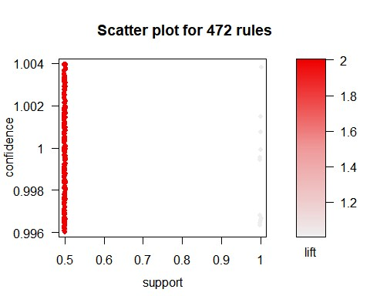

|  |  |
| --- | --- |
| **plot**(rules, method = "graph", interactive = T) | rameter max if needed)      T)] <- NA |
| ## Warning in plot.rules(rules, method = "graph", interactive = T): The ## parameter interactive is deprecated. Use engine='interactive' instead.  ## Warning: plot: Too many rules supplied. Only plotting the best 100 rules ## using 'support' (change control pa  *# Sort by Lift* rules<-**sort**(rules, by="lift", decreasing=TRUE)    *# Sort by Lift* rules<-**sort**(rules, by="lift", decreasing=TRUE)    *# Remove Unnecessary Rules*  subset.matrix <- **is.subset**(rules, rules) subset.matrix[**lower.tri**(subset.matrix, diag= |

|  |
| --- |
| ## Warning in `[<-`(`*tmp*`, as.vector(i), value = NA): x[.] <- val: x is ## "ngTMatrix", val not in {TRUE, FALSE} is coerced; NA |--> TRUE.  redundant <- **colSums**(subset.matrix, na.rm=T) **>=** 1 **which**(redundant)  ## {0,1.25} {0,1.25} {0,1.875}  ## 1 2 3  ## {0,1.875} {0,2.5} {0,2.5} ## 4 5 6  ## {0,3.125} {0,3.125} {1.25,1.875}  ## 7 8 9  ## {1.25,1.875} {1.25,2.5} {1.25,2.5}  ## 10 11 12  ## {1.25,3.125} {1.25,3.125} {1.875,2.5}  ## 13 14 15  ## {1.875,2.5} {1.875,3.125} {1.875,3.125}  ## 16 17 18  ## {2.5,3.125} {2.5,3.125} {0,1.25,1.875}  ## 19 20 21  ## {0,1.25,1.875} {0,1.25,1.875} {0,1.25,2.5}  ## 22 23 24 ## {0,1.25,2.5} {0,1.25,2.5} {0,1.25,3.125}  ## 25 26 27  ## {0,1.25,3.125} {0,1.25,3.125} {0,1.25,3.75}  ## 28 29 30  ## {0,1.25,3.75} {0,1.25,4.375} {0,1.25,4.375}  ## 31 32 33  ## {0,1.25,5} {0,1.25,5} {0,1.875,2.5}  ## 34 35 36  ## {0,1.875,2.5} {0,1.875,2.5} {0,1.875,3.125} ## 37 38 39  ## {0,1.875,3.125} {0,1.875,3.125} {0,1.875,3.75}  ## 40 41 42  ## {0,1.875,3.75} {0,1.875,4.375} {0,1.875,4.375} ## 43 44 45  ## {0,1.875,5} {0,1.875,5} {0,2.5,3.125}  ## 46 47 48  ## {0,2.5,3.125} {0,2.5,3.125} {0,2.5,3.75}  ## 49 50 51  ## {0,2.5,3.75} {0,2.5,4.375} {0,2.5,4.375}  ## 52 53 54  ## {0,2.5,5} {0,2.5,5} {0,3.125,3.75}  ## 55 56 57 ## {0,3.125,3.75} {0,3.125,4.375} {0,3.125,4.375}  ## 58 59 60  ## {0,3.125,5} {0,3.125,5} {1.25,1.875,2.5}  ## 61 62 63  ## {1.25,1.875,2.5} {1.25,1.875,2.5} {1.25,1.875,3.125}  ## 64 65 66 |

## {1.25,1.875,3.125} {1.25,1.875,3.125} {1.25,1.875,3.75}

## 67 68 69

## {1.25,1.875,3.75} {1.25,1.875,4.375} {1.25,1.875,4.375}

## 70 71 72

## {1.25,1.875,5} {1.25,1.875,5} {1.25,2.5,3.125}

## 73 74 75

## {1.25,2.5,3.125} {1.25,2.5,3.125} {1.25,2.5,3.75} ## 76 77 78

## {1.25,2.5,3.75} {1.25,2.5,4.375} {1.25,2.5,4.375}

## 79 80 81

## {1.25,2.5,5} {1.25,2.5,5} {1.25,3.125,3.75}

## 82 83 84

## {1.25,3.125,3.75} {1.25,3.125,4.375} {1.25,3.125,4.375}

## 85 86 87

## {1.25,3.125,5} {1.25,3.125,5} {1.875,2.5,3.125}

## 88 89 90

## {1.875,2.5,3.125} {1.875,2.5,3.125} {1.875,2.5,3.75}

## 91 92 93

## {1.875,2.5,3.75} {1.875,2.5,4.375} {1.875,2.5,4.375}

## 94 95 96

## {1.875,2.5,5} {1.875,2.5,5} {1.875,3.125,3.75}

## 97 98 99

## {1.875,3.125,3.75} {1.875,3.125,4.375} {1.875,3.125,4.375}

## 100 101 102

## {1.875,3.125,5} {1.875,3.125,5} {2.5,3.125,3.75}

## 103 104 105

## {2.5,3.125,3.75} {2.5,3.125,4.375} {2.5,3.125,4.375}

## 106 107 108

## {2.5,3.125,5} {2.5,3.125,5} {0,1.25,1.875,2.5}

## 109 110 111

## {0,1.25,1.875,2.5} {0,1.25,1.875,2.5} {0,1.25,1.875,2.5}

## 112 113 114

## {0,1.25,1.875,3.125} {0,1.25,1.875,3.125} {0,1.25,1.875,3.125}

## 115 116 117

## {0,1.25,1.875,3.125} {0,1.25,1.875,3.75} {0,1.25,1.875,3.75}

## 118 119 120

## {0,1.25,1.875,3.75} {0,1.25,1.875,4.375} {0,1.25,1.875,4.375}

## 121 122 123

## {0,1.25,1.875,4.375} {0,1.25,1.875,5} {0,1.25,1.875,5}

## 124 125 126

## {0,1.25,1.875,5} {0,1.25,2.5,3.125} {0,1.25,2.5,3.125}

## 127 128 129

## {0,1.25,2.5,3.125} {0,1.25,2.5,3.125} {0,1.25,2.5,3.75}

## 130 131 132

## {0,1.25,2.5,3.75} {0,1.25,2.5,3.75} {0,1.25,2.5,4.375}

## 133 134 135

## {0,1.25,2.5,4.375} {0,1.25,2.5,4.375} {0,1.25,2.5,5}

## 136 137 138

## {0,1.25,2.5,5} {0,1.25,2.5,5} {0,1.25,3.125,3.75}

## 139 140 141 ## {0,1.25,3.125,3.75} {0,1.25,3.125,3.75} {0,1.25,3.125,4.375}

## 142 143 144

## {0,1.25,3.125,4.375} {0,1.25,3.125,4.375} {0,1.25,3.125,5}

## 145 146 147

## {0,1.25,3.125,5} {0,1.25,3.125,5} {0,1.25,3.75,4.375} ## 148 149 150

## {0,1.25,3.75,4.375} {0,1.25,3.75,5} {0,1.25,3.75,5}

## 151 152 153

## {0,1.25,4.375,5} {0,1.25,4.375,5} {0,1.875,2.5,3.125}

## 154 155 156

## {0,1.875,2.5,3.125} {0,1.875,2.5,3.125} {0,1.875,2.5,3.125}

## 157 158 159

## {0,1.875,2.5,3.75} {0,1.875,2.5,3.75} {0,1.875,2.5,3.75}

## 160 161 162

## {0,1.875,2.5,4.375} {0,1.875,2.5,4.375} {0,1.875,2.5,4.375}

## 163 164 165

## {0,1.875,2.5,5} {0,1.875,2.5,5} {0,1.875,2.5,5}

## 166 167 168

## {0,1.875,3.125,3.75} {0,1.875,3.125,3.75} {0,1.875,3.125,3.75}

## 169 170 171

## {0,1.875,3.125,4.375} {0,1.875,3.125,4.375} {0,1.875,3.125,4.375}

## 172 173 174

## {0,1.875,3.125,5} {0,1.875,3.125,5} {0,1.875,3.125,5}

## 175 176 177

## {0,1.875,3.75,4.375} {0,1.875,3.75,4.375} {0,1.875,3.75,5}

## 178 179 180

## {0,1.875,3.75,5} {0,1.875,4.375,5} {0,1.875,4.375,5}

## 181 182 183

## {0,2.5,3.125,3.75} {0,2.5,3.125,3.75} {0,2.5,3.125,3.75}

## 184 185 186

## {0,2.5,3.125,4.375} {0,2.5,3.125,4.375} {0,2.5,3.125,4.375}

## 187 188 189

## {0,2.5,3.125,5} {0,2.5,3.125,5} {0,2.5,3.125,5}

## 190 191 192

## {0,2.5,3.75,4.375} {0,2.5,3.75,4.375} {0,2.5,3.75,5}

## 193 194 195

## {0,2.5,3.75,5} {0,2.5,4.375,5} {0,2.5,4.375,5}

## 196 197 198

## {0,3.125,3.75,4.375} {0,3.125,3.75,4.375} {0,3.125,3.75,5}

## 199 200 201

## {0,3.125,3.75,5} {0,3.125,4.375,5} {0,3.125,4.375,5}

## 202 203 204

## {1.25,1.875,2.5,3.125} {1.25,1.875,2.5,3.125} {1.25,1.875,2.5,3.125} ## 205 206 207

## {1.25,1.875,2.5,3.125} {1.25,1.875,2.5,3.75} {1.25,1.875,2.5,3.75}

## 208 209 210 ## {1.25,1.875,2.5,3.75} {1.25,1.875,2.5,4.375} {1.25,1.875,2.5,4.375}

## 211 212 213

## {1.25,1.875,2.5,4.375} {1.25,1.875,2.5,5} {1.25,1.875,2.5,5}

## 214 215 216 ## {1.25,1.875,2.5,5} {1.25,1.875,3.125,3.75} {1.25,1.875,3.125,3.75}

## 217 218 219

## {1.25,1.875,3.125,3.75} {1.25,1.875,3.125,4.375} {1.25,1.875,3.125,4.375}

## 220 221 222

## {1.25,1.875,3.125,4.375} {1.25,1.875,3.125,5} {1.25,1.875,3.125,5}

## 223 224 225 ## {1.25,1.875,3.125,5} {1.25,1.875,3.75,4.375} {1.25,1.875,3.75,4.375} ## 226 227 228

## {1.25,1.875,3.75,5} {1.25,1.875,3.75,5} {1.25,1.875,4.375,5}

## 229 230 231

## {1.25,1.875,4.375,5} {1.25,2.5,3.125,3.75} {1.25,2.5,3.125,3.75}

## 232 233 234

## {1.25,2.5,3.125,3.75} {1.25,2.5,3.125,4.375} {1.25,2.5,3.125,4.375}

## 235 236 237

## {1.25,2.5,3.125,4.375} {1.25,2.5,3.125,5} {1.25,2.5,3.125,5}

## 238 239 240

## {1.25,2.5,3.125,5} {1.25,2.5,3.75,4.375} {1.25,2.5,3.75,4.375}

## 241 242 243

## {1.25,2.5,3.75,5} {1.25,2.5,3.75,5} {1.25,2.5,4.375,5}

## 244 245 246

## {1.25,2.5,4.375,5} {1.25,3.125,3.75,4.375} {1.25,3.125,3.75,4.375}

## 247 248 249

## {1.25,3.125,3.75,5} {1.25,3.125,3.75,5} {1.25,3.125,4.375,5}

## 250 251 252

## {1.25,3.125,4.375,5} {1.875,2.5,3.125,3.75} {1.875,2.5,3.125,3.75}

## 253 254 255

## {1.875,2.5,3.125,3.75} {1.875,2.5,3.125,4.375} {1.875,2.5,3.125,4.375}

## 256 257 258

## {1.875,2.5,3.125,4.375} {1.875,2.5,3.125,5} {1.875,2.5,3.125,5}

## 259 260 261

## {1.875,2.5,3.125,5} {1.875,2.5,3.75,4.375} {1.875,2.5,3.75,4.375}

## 262 263 264

## {1.875,2.5,3.75,5} {1.875,2.5,3.75,5} {1.875,2.5,4.375,5}

## 265 266 267

## {1.875,2.5,4.375,5} {1.875,3.125,3.75,4.375} {1.875,3.125,3.75,4.375}

## 268 269 270

## {1.875,3.125,3.75,5} {1.875,3.125,3.75,5} {1.875,3.125,4.375,5}

## 271 272 273

## {1.875,3.125,4.375,5} {2.5,3.125,3.75,4.375} {2.5,3.125,3.75,4.375}

## 274 275 276

## {2.5,3.125,3.75,5} {2.5,3.125,3.75,5} {2.5,3.125,4.375,5}

## 277 278 279

## {2.5,3.125,4.375,5} {3.75} {4.375}

## 280 281 282

## {5} {0,3.75} {0,4.375}

## 283 284 285

## {0,5} {1.25,3.75} {1.25,4.375}

## 286 287 288

## {1.25,5} {1.875,3.75} {1.875,4.375}

## 289 290 291 ## {1.875,5} {2.5,3.75} {2.5,4.375}

## 292 293 294

## {2.5,5} {3.125,3.75} {3.125,4.375}

## 295 296 297 ## {3.125,5} {3.75,4.375} {3.75,4.375}

## 298 299 300

## {3.75,5} {3.75,5} {4.375,5}

## 301 302 303

## {4.375,5} {0,1.25,3.75} {0,1.25,4.375}

## 304 305 306

## {0,1.25,5} {0,1.875,3.75} {0,1.875,4.375}

## 307 308 309

## {0,1.875,5} {0,2.5,3.75} {0,2.5,4.375}

## 310 311 312

## {0,2.5,5} {0,3.125,3.75} {0,3.125,4.375}

## 313 314 315

## {0,3.125,5} {0,3.75,4.375} {0,3.75,4.375}

## 316 317 318

## {0,3.75,5} {0,3.75,5} {0,4.375,5}

## 319 320 321

## {0,4.375,5} {1.25,1.875,3.75} {1.25,1.875,4.375}

## 322 323 324

## {1.25,1.875,5} {1.25,2.5,3.75} {1.25,2.5,4.375}

## 325 326 327

## {1.25,2.5,5} {1.25,3.125,3.75} {1.25,3.125,4.375}

## 328 329 330

## {1.25,3.125,5} {1.25,3.75,4.375} {1.25,3.75,4.375}

## 331 332 333

## {1.25,3.75,5} {1.25,3.75,5} {1.25,4.375,5}

## 334 335 336

## {1.25,4.375,5} {1.875,2.5,3.75} {1.875,2.5,4.375}

## 337 338 339

## {1.875,2.5,5} {1.875,3.125,3.75} {1.875,3.125,4.375}

## 340 341 342

## {1.875,3.125,5} {1.875,3.75,4.375} {1.875,3.75,4.375}

## 343 344 345

## {1.875,3.75,5} {1.875,3.75,5} {1.875,4.375,5}

## 346 347 348

## {1.875,4.375,5} {2.5,3.125,3.75} {2.5,3.125,4.375}

## 349 350 351

## {2.5,3.125,5} {2.5,3.75,4.375} {2.5,3.75,4.375}

## 352 353 354

## {2.5,3.75,5} {2.5,3.75,5} {2.5,4.375,5}

## 355 356 357

## {2.5,4.375,5} {3.125,3.75,4.375} {3.125,3.75,4.375}

## 358 359 360

## {3.125,3.75,5} {3.125,3.75,5} {3.125,4.375,5}

## 361 362 363

## {3.125,4.375,5} {3.75,4.375,5} {3.75,4.375,5}

## 364 365 366 ## {3.75,4.375,5} {0,1.25,1.875,3.75} {0,1.25,1.875,4.375}

## 367 368 369 ## {0,1.25,1.875,5} {0,1.25,2.5,3.75} {0,1.25,2.5,4.375}

## 370 371 372

## {0,1.25,2.5,5} {0,1.25,3.125,3.75} {0,1.25,3.125,4.375}

## 373 374 375

## {0,1.25,3.125,5} {0,1.25,3.75,4.375} {0,1.25,3.75,4.375}

## 376 377 378

## {0,1.25,3.75,5} {0,1.25,3.75,5} {0,1.25,4.375,5}

## 379 380 381

## {0,1.25,4.375,5} {0,1.875,2.5,3.75} {0,1.875,2.5,4.375}

## 382 383 384

## {0,1.875,2.5,5} {0,1.875,3.125,3.75} {0,1.875,3.125,4.375}

## 385 386 387

## {0,1.875,3.125,5} {0,1.875,3.75,4.375} {0,1.875,3.75,4.375}

## 388 389 390

## {0,1.875,3.75,5} {0,1.875,3.75,5} {0,1.875,4.375,5}

## 391 392 393

## {0,1.875,4.375,5} {0,2.5,3.125,3.75} {0,2.5,3.125,4.375}

## 394 395 396

## {0,2.5,3.125,5} {0,2.5,3.75,4.375} {0,2.5,3.75,4.375}

## 397 398 399

## {0,2.5,3.75,5} {0,2.5,3.75,5} {0,2.5,4.375,5}

## 400 401 402

## {0,2.5,4.375,5} {0,3.125,3.75,4.375} {0,3.125,3.75,4.375}

## 403 404 405

## {0,3.125,3.75,5} {0,3.125,3.75,5} {0,3.125,4.375,5}

## 406 407 408

## {0,3.125,4.375,5} {0,3.75,4.375,5} {0,3.75,4.375,5}

## 409 410 411

## {0,3.75,4.375,5} {1.25,1.875,2.5,3.75} {1.25,1.875,2.5,4.375}

## 412 413 414

## {1.25,1.875,2.5,5} {1.25,1.875,3.125,3.75} {1.25,1.875,3.125,4.375}

## 415 416 417

## {1.25,1.875,3.125,5} {1.25,1.875,3.75,4.375} {1.25,1.875,3.75,4.375}

## 418 419 420

## {1.25,1.875,3.75,5} {1.25,1.875,3.75,5} {1.25,1.875,4.375,5}

## 421 422 423

## {1.25,1.875,4.375,5} {1.25,2.5,3.125,3.75} {1.25,2.5,3.125,4.375}

## 424 425 426

## {1.25,2.5,3.125,5} {1.25,2.5,3.75,4.375} {1.25,2.5,3.75,4.375}

## 427 428 429

## {1.25,2.5,3.75,5} {1.25,2.5,3.75,5} {1.25,2.5,4.375,5}

## 430 431 432

## {1.25,2.5,4.375,5} {1.25,3.125,3.75,4.375} {1.25,3.125,3.75,4.375}

## 433 434 435

## {1.25,3.125,3.75,5} {1.25,3.125,3.75,5} {1.25,3.125,4.375,5}

## 436 437 438

## {1.25,3.125,4.375,5} {1.25,3.75,4.375,5} {1.25,3.75,4.375,5}

## 439 440 441

|  |
| --- |
| ## {1.25,3.75,4.375,5} {1.875,2.5,3.125,3.75} {1.875,2.5,3.125,4.375}  ## 442 443 444  ## {1.875,2.5,3.125,5} {1.875,2.5,3.75,4.375} {1.875,2.5,3.75,4.375}  ## 445 446 447  ## {1.875,2.5,3.75,5} {1.875,2.5,3.75,5} {1.875,2.5,4.375,5}  ## 448 449 450  ## {1.875,2.5,4.375,5} {1.875,3.125,3.75,4.375} {1.875,3.125,3.75,4.375}  ## 451 452 453  ## {1.875,3.125,3.75,5} {1.875,3.125,3.75,5} {1.875,3.125,4.375,5}  ## 454 455 456  ## {1.875,3.125,4.375,5} {1.875,3.75,4.375,5} {1.875,3.75,4.375,5}  ## 457 458 459  ## {1.875,3.75,4.375,5} {2.5,3.125,3.75,4.375} {2.5,3.125,3.75,4.375} ## 460 461 462  ## {2.5,3.125,3.75,5} {2.5,3.125,3.75,5} {2.5,3.125,4.375,5}  ## 463 464 465  ## {2.5,3.125,4.375,5} {2.5,3.75,4.375,5} {2.5,3.75,4.375,5}  ## 466 467 468  ## {2.5,3.75,4.375,5} {3.125,3.75,4.375,5} {3.125,3.75,4.375,5}  ## 469 470 471 ## {3.125,3.75,4.375,5} ## 472  rules.pruned <- rules[**!**redundant] rules<-rules.pruned rules  ## set of 0 rules  *#Clean Rules*  rules3**$**rules=**gsub**("\\{", "", rules3**$**rules) rules3**$**rules=**gsub**("\\}", "", rules3**$**rules) rules3**$**rules=**gsub**("\"", "", rules3**$**rules)    *#Split the rule*  **library**(splitstackshape)  Rules4=**cSplit**(rules3, "rules","=>")  **names**(Rules4)[**names**(Rules4) **==** 'rules_1'] <- 'LHS'  Rules5=**cSplit**(Rules4, "LHS",",")  Rules6=**subset**(Rules5, select= **-c**(rules_2))  **names**(Rules6)[**names**(Rules6) **==** 'rules_3'] <- 'RHS'    *# What are customers likely to buy before they purchase "Product A"* rules<-**apriori**(data=dt, parameter=**list**(supp=0.001,conf = 0.8), appearance = **list**(default="lhs",rhs="0"), control = **list**(verbose=F))  ## Warning in asMethod(object): removing duplicated items in transactions  rules<-**sort**(rules, decreasing=TRUE,by="confidence") **inspect**(rules[1**:**5]) |

|  |
| --- |
| ## lhs rhs support confidence lift count  ## [1] {1.25} => {0} 0.5 1 2 1  ## [2] {1.875} => {0} 0.5 1 2 1  ## [3] {2.5} => {0} 0.5 1 2 1  ## [4] {3.125} => {0} 0.5 1 2 1  ## [5] {1.25,1.875} => {0} 0.5 1 2 1  *# What are customers likely to buy if they purchased "Product A"* rules<-**apriori**(data=dt, parameter=**list**(supp=0.001,conf = 0.8), appearance = **list**(default="rhs",lhs="0"), control = **list**(verbose=F))  ## Warning in asMethod(object): removing duplicated items in transactions  rules<-**sort**(rules, decreasing=TRUE,by="confidence") **inspect**(rules[1**:**5])  ## lhs rhs support confidence lift count  ## [1] {} => {3.75} 1.0 1 1 2  ## [2] {} => {4.375} 1.0 1 1 2  ## [3] {} => {5} 1.0 1 1 2  ## [4] {0} => {1.25} 0.5 1 2 1 ## [5] {0} => {1.875} 0.5 1 2 1 rules  ## set of 10 rules  support<-**seq**(0.01,0.1,0.01) support  ## [1] 0.01 0.02 0.03 0.04 0.05 0.06 0.07 0.08 0.09 0.10  rules_count<-**c**(472,128,46,26,14, 10, 10,8,8,8) rules_count  ## [1] 472 128 46 26 14 10 10 8 8 8  **plot**(support,rules_count,type = "l",main="Number of rules at different suppor t %",  col="darkred",lwd=3) |

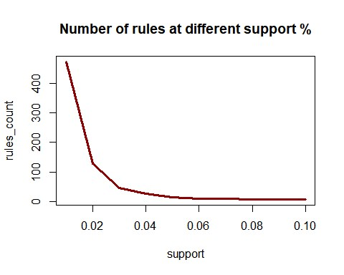

|  |  |
| --- | --- |
| conf<-**seq**(0.10,1.0,0.10) | 125,62,15,0,0,0,0,0)    type = "l",main="Number of rules at different confidenc |
| conf  ## [1] 0.1 0.2 0.3 0.4 0.5 0.6 0.7 0.8 0.9 1.0  rules_count<-**c**(472,231, rules_count  ## [1] 472 231 125 62 15 0 0 0 0 0  **plot**(conf,rules_count, e %", |

|  |  |
| --- | --- |
| col="darkred",lwd=3) | *eclat(epi_r, parameter = list(supp = 0.05))*    "confidence", decreasing=TRUE)  support confidence lift count ## [1] {} => {3.75} 1.0 1 1 2  ## [2] {} => {4.375} 1.0 1 1 2  ## [3] {} => {5} 1.0 1 1 2  ## [4] {0} => {1.25} 0.5 1 2 1  1 2 1  "lift", decreasing=TRUE)  ## lhs rhs support confidence lift count  ## [1] {0} => {1.25} 0.5 1 2 1  ## [2] {0} => {1.875} 0.5 1 2 1  {2.5} 0.5 1 2 1  ## [4] {0} => {3.125} 0.5 1 2 1 |
| *#rules_ec <-*    *#summary(rules_ec)*    *#sorting out the most relevant rules* rules<-**sort**(rules, by= **inspect**(rules[1**:**5])  ## lhs rhs  ## [5] {0} => {1.875} 0.5  rules<-**sort**(rules, by= **inspect**(rules[1**:**5])  ## [3] {0} =>  ## [5] {} => {3.75} 1.0 1 1 2 |

|  |  |
| --- | --- |
| ######################################## | e! Related Books: `Practical Guide To Cluster Analysis in R` at http  it  Ham Persilla      Banana-Cho    Mozzar      Asian Pe |
| **library**(factoextra)  ## Loading required package: ggplot2  ## Welcom s://goo.gl/13EFCZ  **library**("factoextra") data1<-**na.exclude**(data) **na.omit**(data1)  ##  title  ## 1  Lentil, Apple, and Turkey Wrap  ## 2 Boudin Blanc Terrine with Red Onion Conf  ## 3  Potato and Fennel Soup Hodge  ## 5  Spinach Noodle Casserole  ## 6  The Best Blts  ## 9  Korean Marinated Beef  ## 10 de with Mustard Potato Salad and Mashed Peas  ## 11  Yams Braised with Cream, Rosemary and Nutmeg  ## 13 colate Chip Cake With Peanut Butter Frosting  ## 14  Beef Tenderloin with Garlic and Brandy  ## 15 Peach Mustard  ## 16  Raw Cream of Spinach Soup  ## 17  Sweet Buttermilk Spoon Breads  ## 18  Crisp Braised Pork Shoulder  ## 19 ella-Topped Peppers with Tomatoes and Garlic  ## 20 Tuna, Asparagus, and New Potato S alad with Chive Vinaigrette and Fried Capers  ## 21 ar and Watercress Salad with Sesame Dressing  ## 25  Sea Salt-Roasted Pecans  ## 26 |

Garlic Baguette Crumbs

## 27

|  |
| --- |
| Cucumber-Basil Egg Salad  ## 28 Dried Pear Crisps  ## 29 Green Bean, Red Onion, and Roast Potato Salad with Rosemary Vinaigrette  ## 30 Apricot-Cherry Shortcakes  ## 33 Roaste d Sweet-Potato Spears with Bacon Vinaigrette  ## 34  Deviled Ham  ## 36  Aztec Chicken  ## 38  Sauteed Broccoli Rabe  ## 39  Grouper with Tomato and Basil  ## 40  Better-Than-Pita Grill Bread  ## 41 Coconut-Key Lime Sheet Cake  ## 42 Baked Hal ibut with Orzo, Spinach, and Cherry Tomatoes  ## 46 Pickled Red Onions  ## 47 Spicy Black Beans and Rice  ## 49 Mexican Lime Soup  ## 50 Citrus Salad with Mint Sugar  ## 51 Mexican Chile and Mushroom Soup  ## 52 Peanut Butter-Banana Muffins  ## 54 Pancetta Roast Chicken with Walnut Stuffing  ## 55 1977 Coconut Angel Food Cake  ## 57 Veal Burgers Stuffed with Mozzarella Cheese  ## 58 Pumpkin Muffins  ## 59 Orange Balsamic Glaze  ## 60 Roasted Egg plant and Olive Spread with Pita Bread Chips  ## 61 |

Pecan Blue Cheese Crackers

## 62 Romaine, Grilled Avocado, and Sm

|  |
| --- |
| oky Corn Salad with Chipotle-Caesar Dressing  ## 63 Southwest Cor n Bread Stuffing with Corn and Green Chilies  ## 64 Coli n Perryâ\200\231s Sorghum and Apple Sticky Pudding  ## 65 Mixed Berry Pavlovas  ## 67  Scarborough Fair Tofu Burger  ## 68 Italian Vinaigrette  ## 69 White Choc olate Tartlets with Strawberries and Bananas  ## 70  Tomato-Infused Bulgur Pilaf with Fresh Basil  ## 71 Roasted Bu tternut Squash, Rosemary, and Garlic Lasagne  ## 72 Grilled Roast Beef and Stilton Sandwich  ## 73 Pear-Ha zelnut Cheesecakes with Pear-Raspberry Sauce  ## 74 Nut Butter  ## 75 Cheese Ravioli with Fresh Tomato Sauce  ## 76 Banana Layer Cake with Cream Cheese Frosting  ## 77 S outh American-Style JÃ-cama and Orange Salad  ## 78 Roasted Acorn Squash and Chestnuts  ## 79 Maple Pumpkin Pots de CrÃ¨me  ## 81 Braised Chicken and Rice with Orange, Saffron, Almond, and Pistachio Syrup  ## 82 Horseradish Dill Potato Salad  ## 83  Chicken in Green Pumpkin-Seed Sauce  ## 84 Jeweled Rice  ## 85  Braised Brisket with Bourbon-Peach Glaze  ## 86 Gr illed Pork Chops with Classic Barbecue Sauce  ## 88 Roast Chicken With Sorghum and Squash  ## 89 |

Asparagus with Bacon and Onion

## 92

|  |
| --- |
| Salmon with Chili-Mango Salsa  ## 93  Turkey and Pinto Bean Chili  ## 94 Cucumber-Yogurt Salad with Mint  ## 95 Lamb Shanks Braised with Anise and Orange  ## 96 Parsley Mayo  ## 97  Acini di Pepe Pasta with Garlic and Olives  ## 98 R oast Beef Salad with Cabbage and Horseradish  ## 99 Savoy Cabbage and Arugula Salad  ## 100  Fennel, Beet and Orange Salad with Olives  ## 101  Shrimp Gazpacho  ## 103 Parsnip and Apple Soup  ## 105 Stout Floats  ## 106  Apricot-Pistachio Muffins Baked on the Grill  ## 107 Garlic Bruschetta  ## 108 Asian Noodles with Barbecued Duck Confit  ## 110 Banan a Split with Curried Chocolate-Coconut Sauce  ## 111 Escarole and Cheese Spoon Bread  ## 112 Honey-Ginger Barbecue Sauce  ## 114 Kids' Matzoh Pizza  ## 115 Cranberry, Quince, and Pearl Onion Compote  ## 117 Tropical Rum Punch  ## 118 Chickpea S alad Sandwich With Creamy Carrot-Radish Slaw  ## 119 Blackberry-Raspberry Sauce  ## 120 Laddie's Sub-Bourbon  ## 121 |

Red Cabbage and Onions

## 122

|  |
| --- |
| Roast Cod with Potatoes, Onions, and Olives  ## 123 Spicy Tomato Sauce  ## 125 Swiss Chard with Roasted Pepper  ## 126  Chocolate Almond Butter  ## 127 Pastry Dough  ## 129 Spicy Sesame  Noodles with Chopped Peanuts and Thai Basil  ## 130 Potato Gratin with Goat Cheese and Garlic  ## 131 Country Sausage and Sage Dressing  ## 133 Buttermilk-Spinach Spaetzle  ## 134 Radishes with Burrata  ## 135 Winter Squash SoufflÃ©  ## 136 Blueberry Streusel Cake  ## 137 Low-Fat Chicken Stock  ## 138 Honey Mustard Sauce  ## 139  Rosemary and Lemon Pinto Beans  ## 140 Asian Dipping Sauce  ## 141  Shrimp and Green Onion Pancakes  ## 143 Mustard-Ginger Shrimp Canapes  ## 144 Rumbrosia  ## 146 Thai Vegetables  ## 147 Sage-Roasted T urkey with Caramelized Onions and Sage Gravy  ## 148 Shrimp Cakes with Andouille Sausage  ## 149 Creamy Tofu Salad  ## 150 Chocola te-Cherry Ice Cream Pie with Hot Fudge Sauce  ## 151 |

JalapeÃ±o-Cheddar Frittata

## 152

Roasted Beets and Citrus with Feta

## 153 Gree n Beans with Crisp Shallots, Chile, and Mint

## 155

Cranberry Pear Tart with Gingerbread Crust

## 156 Sauteed Veal w ith Shrimp, Mushroom, and Brandy Cream Sauce

## 157 Lemon Vinaigrette

## 159

Cranberry, Shallot, and Dried-Cherry Compote

## 161 Peanut Butter Cream Tart

## 162

Cheddar Chicken Tenders with Wilted Spinach

## 163 Blueberry Cheesecake

## 165

Apple Pie with Whisky-Soaked Cherries

## 166 Parsleyed Yellow-Potato Salad

## 167 Sauteed Fennel and Carrots

## 168 Gr illed Garlic-Marinated Skirt Steak with Lime

## 169

Miniature Crab Cakes with Tomato Ginger Jam

## 170 Egg Sandwich with Green Bean Slaw

## 171

Red Wine Brasato with Glazed Root Vegetables

## 173 Egg Salad with Lemon and Fennel

## 175

Shaved Brussels Sprout and Shallot SautÃ©

## 177 Roasted Carrot and Beet Salad with Feta

## 178 Cassata Cake

## 179

Baked Beans with Slab Bacon and Breadcrumbs

## 180

Grilled Corn with Lime-Cilantro Butter

## 181 Roasted Winter Squash and Parsnip s with Maple Syrup Glaze and Marcona Almonds

## 185 Roasted

Bell Peppers with Basil and Balsamic Vinegar

## 186 Homemade Tomato Ketchup

## 188 Char-Grilled

Beef Tenderloin with Three-Herb Chimichurri

## 189 Pork Roast Braised with Milk and Fresh Herbs (Maiale al Latte )

## 191 Chocolate Pecan Banana Tarts

## rating calories protein fat sodium X.cakeweek X.wasteless

## 1 2.5 4.3e+02 30 7 5.6e+02 0 0

## 2 4.4 4.0e+02 18 23 1.4e+03 0 0

## 3 3.8 1.6e+02 6 7 1.6e+02 0 0

## 5 3.1 5.5e+02 20 32 4.5e+02 0 0

## 6 4.4 9.5e+02 19 79 1.0e+03 0 0

## 9 4.4 1.7e+02 7 10 1.3e+03 0 0

## 10 3.8 6.0e+02 23 41 1.7e+03 0 0

## 11 3.8 2.6e+02 4 5 3.0e+01 0 0

## 13 4.4 7.7e+02 12 48 4.4e+02 0 0

## 14 4.4 1.7e+02 11 12 1.8e+02 0 0

## 15 3.1 1.3e+02 4 3 1.4e+03 0 0

## 16 4.4 3.8e+02 5 31 9.8e+02 0 0

## 17 1.9 1.5e+02 4 5 1.6e+02 0 0

## 18 4.4 8.9e+02 59 68 1.0e+03 0 0

## 19 5.0 1.1e+02 5 7 3.4e+02 0 0

## 20 5.0 4.2e+02 10 33 3.8e+02 0 0

## 21 4.4 3.4e+02 11 19 4.2e+02 0 0

## 25 3.8 2.8e+02 3 30 2.1e+02 0 0

## 26 0.0 9.5e+01 1 7 1.0e+02 0 0

## 27 3.8 2.2e+02 6 20 2.5e+02 0 0

## 28 2.5 1.4e+01 0 0 0.0e+00 0 0

## 29 4.4 3.5e+02 6 19 7.9e+01 0 0

## 30 4.4 3.1e+02 5 5 2.3e+02 0 0

## 33 4.4 3.8e+02 7 18 6.0e+02 0 0

## 34 3.1 1.8e+02 10 13 7.6e+02 0 0

## 36 3.8 6.2e+02 39 44 1.2e+03 0 0

## 38 4.4 1.1e+02 4 10 3.3e+02 0 0

## 39 4.4 3.4e+02 44 16 4.1e+02 0 0

## 40 2.5 1.4e+02 3 6 2.1e+02 0 0

## 41 4.4 4.8e+02 5 35 1.0e+02 0 0

## 42 4.4 6.3e+02 44 31 1.8e+02 0 0

## 46 4.4 9.0e+01 2 0 8.8e+02 0 0

## 47 3.8 2.0e+02 19 8 8.2e+02 0 0

## 49 4.4 3.4e+02 14 21 1.7e+02 0 0

## 50 4.4 1.9e+02 3 1 4.0e+00 0 0

## 51 3.1 1.7e+02 8 12 5.1e+02 0 0

## 52 3.8 2.8e+02 6 13 2.4e+02 0 0

## 54 5.0 1.2e+03 89 87 5.8e+02 0 0

## 55 3.8 2.7e+02 4 7 1.5e+02 0 0

## 57 4.4 9.0e+02 38 70 1.4e+03 0 0

## 58 4.4 2.2e+02 4 10 2.1e+02 0 0

## 59 3.8 1.9e+02 2 3 7.0e+02 0 0

|  |
| --- |
| ## 60 3.8 1.8e+02 5 7 1.2e+02 0 0 ## 61 3.8 7.0e+01 2 6 6.0e+01 0 0    ## 127 0 0 0 0 0 0  ## 129 0 0 0 0 0 0  ## 130 0 0 0 0 0 0  ## 131 0 0 0 0 0 0  ## 133 0 0 0 0 0 0 ## 134 0 0 0 0 0 0  1 0 0 0 0 0 0 0  ## 62 0 0 0 0 0 0 0  ## 63 0 0 0 0 0 0 0  ## 64 0 0 0 0 0 0 0  ## 65 0 0 0 0 0 0 0  ## 67 0 0 0 0 0 0 0  ## 68 0 0 0 0 0 0 0  ## 69 0 0 0 0 0 0 0  ## 70 0 0 0 0 0 0 0  ## 71 0 0 0 0 0 0 0  ## 72 0 0 0 0 0 0 0  ## 73 0 0 0 0 0 0 0  ## 74 0 0 0 0 0 0 0  ## 75 0 0 0 0 0 0 0  ## 76 0 0 0 0 0 0 0  ## 77 0 0 0 0 0 0 0  ## 78 0 0 0 0 0 0 0  ## 79 0 0 0 0 0 0 0  ## 81 1 0 0 0 0 0 0  ## 82 0 0 0 0 0 0 0  ## 83 0 0 0 0 0 0 0  ## 84 1 0 0 0 0 0 0  ## 85 0 0 0 0 0 0 0  ## 86 0 0 0 0 0 0 0  ## 88 0 0 0 0 0 0 0  ## 89 0 0 0 0 0 0 0  ## 92 0 0 0 0 0 0 0  ## 93 0 0 0 0 0 0 0  ## 94 0 0 0 0 0 0 0  ## 95 0 0 0 0 0 0 0  ## 96 0 0 0 0 0 0 0  ## 97 0 0 0 0 0 0 0  ## 98 0 0 0 0 0 0 0  ## 99 0 0 0 0 0 0 0  ## 100 0 0 0 0 0 0 0  ## 101 0 0 0 0 0 0 0  ## 103 0 0 0 0 0 0 0  ## 105 0 0 0 0 0 0 0  ## 106 1 0 0 0 0 0 0  ## 107 0 0 0 0 0 0 0  ## 108 0 0 0 0 0 0 0 |

|  |
| --- |
| ## 110 0 0 0 0 0 0 0  ## 111 0 0 0 0 0 0 0  ## 112 0 0 0 0 0 0 0 ## 114 0 0 0 0 0 0 0    ## 191 0 0  ## [ reached getOption("max.print") -- omitted 15717 rows ]  data1.active <- data1[2**:**100, 2**:**6] **na.exclude**(data1.active)  ## rating calories protein fat sodium  ## 2 4.4 403 18 23 1439  ## 3 3.8 165 6 7 165  ## 5 3.1 547 20 32 452  ## 6 4.4 948 19 79 1042  ## 9 4.4 170 7 10 1272  ## 10 3.8 602 23 41 1696  ## 11 3.8 256 4 5 30  ## 13 4.4 766 12 48 439  ## 14 4.4 174 11 12 176  ## 15 3.1 134 4 3 1394  ## 16 4.4 382 5 31 977  ## 17 1.9 146 4 5 160  ## 18 4.4 890 59 68 1027  ## 19 5.0 107 5 7 344  ## 20 5.0 421 10 33 383  ## 21 4.4 345 11 19 423  ## 25 3.8 279 3 30 206  ## 26 0.0 95 1 7 103  ## 27 3.8 215 6 20 250  ## 28 2.5 14 0 0 0  ## 29 4.4 351 6 19 79  ## 30 4.4 311 5 5 226  ## 33 4.4 376 7 18 604  ## 34 3.1 185 10 13 765  ## 36 3.8 625 39 44 1248  ## 38 4.4 107 4 10 329  ## 39 4.4 336 44 16 413  ## 40 2.5 145 3 6 208  ## 41 4.4 483 5 35 100  ## 42 4.4 634 44 31 181  ## 46 4.4 90 2 0 881  ## 47 3.8 202 19 8 815  ## 49 4.4 338 14 21 174  ## 50 4.4 191 3 1 4  ## 51 3.1 166 8 12 508  ## 52 3.8 275 6 13 242  ## 54 5.0 1203 89 87 583  ## 55 3.8 266 4 7 148 |

|  |
| --- |
| ## 57 4.4 904 38 70 1413  ## 58 4.4 223 4 10 211  ## 59 3.8 194 2 3 697  ## 60 3.8 177 5 7 116  ## 61 3.8 70 2 6 60  ## 62 4.4 368 6 32 112  ## 63 5.0 293 7 15 565  ## 64 0.0 523 8 19 694  ## 65 3.8 252 4 7 89  ## 67 3.1 224 21 12 340  ## 68 3.8 185 0 20 155  ## 69 4.4 830 9 59 148  ## 70 0.0 195 7 5 469  ## 71 4.4 684 21 42 637  ## 72 4.4 641 39 37 907  ## 73 3.8 538 8 36 231  ## 74 3.8 264 7 24 84  ## 75 3.8 365 19 14 599  ## 76 4.4 926 9 56 569  ## 77 3.1 26 1 0 364  ## 78 3.8 230 2 7 9  ## 79 4.4 157 3 8 51  ## 81 4.4 1172 54 73 220  ## 82 4.4 298 6 12 199  ## 83 4.4 682 36 57 909  ## 84 5.0 517 7 18 20  ## 85 4.4 856 45 54 1797  ## 86 4.4 599 48 28 1038  ## 88 0.0 1143 63 77 311  ## 89 4.4 129 4 11 146  ## 92 4.4 571 36 37 106  ## 93 4.4 508 45 17 826  ## 94 3.8 62 2 3 603  ## 95 3.1 1118 92 70 1226  ## 96 0.0 306 0 34 302  ## 97 4.4 209 5 8 77  ## 98 3.1 645 22 52 324  ## 99 3.1 126 3 9 46  ## 100 4.4 133 2 8 91  ## 101 4.4 285 19 7 635  ## 103 4.4 310 3 25 89  ## 105 3.1 248 3 10 73  ## 106 5.0 247 5 10 185  ## 107 3.8 201 4 11 210  ## 108 5.0 519 14 25 1237  ## 110 3.8 1076 11 73 150  ## 111 4.4 338 15 18 515  ## 112 4.4 298 1 0 1430  ## 114 3.1 280 13 18 587  ## 115 3.8 171 1 0 6 |

|  |
| --- |
| ## 117 5.0 230 1 0 26  ## 118 3.8 959 21 60 1541  ## 119 4.4 129 1 0 2  ## 120 2.5 107 0 0 0  ## 121 3.8 86 3 1 339  ## 122 3.8 679 55 36 333  ## 123 0.0 112 2 7 12  ## 125 3.8 123 5 7 605  ## 126 0.0 273 2 28 5  ## 127 5.0 234 3 16 99  ## 129 4.4 724 21 28 1130  **View**(data1.active) **head**(data1.active[, 2**:**5])  ## calories protein fat sodium  ## 2 403 18 23 1439  ## 3 165 6 7 165  ## 5 547 20 32 452  ## 6 948 19 79 1042  ## 9 170 7 10 1272  ## 10 602 23 41 1696  *#Compute PCA in R using prcomp()* **library**(factoextra)  res.pca <- **prcomp**(data1.active, scale = TRUE) res.pca  ## Standard deviations (1, .., p=5):  ## [1] 1.70 1.00 0.86 0.58 0.22  ##  ## Rotation (n x k) = (5 x 5):  ## PC1 PC2 PC3 PC4 PC5  ## rating -0.11 0.943 0.311 0.0031 -0.038  ## calories -0.56 -0.105 0.208 -0.2732 0.746  ## protein -0.51 -0.085 0.052 0.8484 -0.099  ## fat -0.54 -0.169 0.241 -0.4344 -0.657 ## sodium -0.35 0.253 -0.894 -0.1299 -0.023 **summary**(res.pca)  ## Importance of components:  ## PC1 PC2 PC3 PC4 PC5  ## Standard deviation 1.696 1.002 0.856 0.579 0.2243  ## Proportion of Variance 0.575 0.201 0.147 0.067 0.0101 ## Cumulative Proportion 0.575 0.776 0.923 0.990 1.0000 **fviz_eig**(res.pca) |

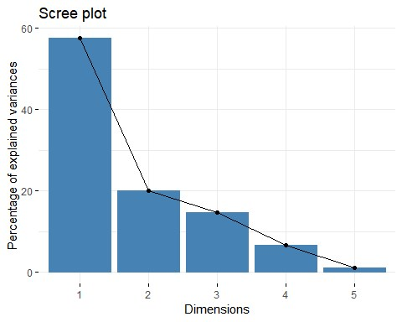

|  |  |
| --- | --- |
| **fviz_pca_ind**(res.pca, | "cos2", *# Color by the quality of representation* **c**("#00AFBB", "#E7B800", "#FC4E07"),  TRUE *# Avoid text overlapping* |
| col.ind = gradient.cols = repel =  ) |

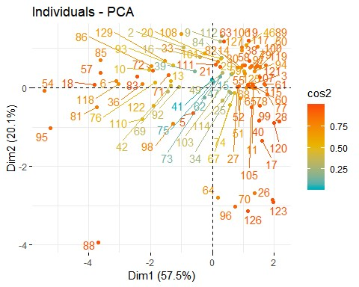

|  |  |
| --- | --- |
| **fviz_pca_var**(res.pca, | "contrib", *# Color by contributions to the PC* **c**("#00AFBB", "#E7B800", "#FC4E07"),  TRUE *# Avoid text overlapping* |
| col.var = gradient.cols = repel =  ) |

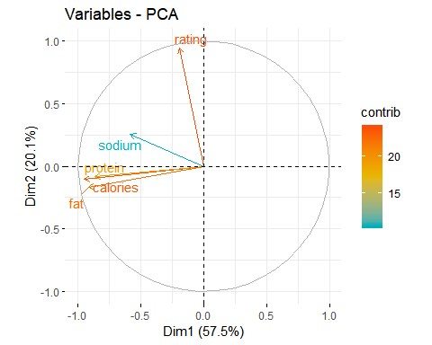

|  |  |
| --- | --- |
| **fviz_pca_biplot**(res.pca, repel = TRUE, | *# Variables color*  *# Individuals color* |
| col.var = "#2E9FDF", col.ind = "#696969"  ) |

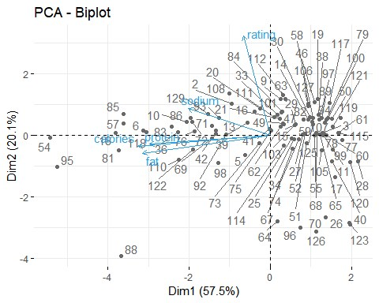

|  |  |
| --- | --- |
| **library**(factoextra) | (res.pca)  ## eigenvalue variance.percent cumulative.variance.percent  ## Dim.1 2.88 57.5 58  ## Dim.2 1.00 20.1 78  ## Dim.3 0.73 14.7 92  ## Dim.4 0.33 6.7 99 ## Dim.5 0.05 1.0 100    (res.pca)  *# Coordinates*  ## Dim.1 Dim.2 Dim.3 Dim.4 Dim.5  0.945 0.267 0.0018 -0.0084  0.105 0.178 -0.1581 0.1674 0.085 0.045 0.4911 -0.0223 0.169 0.207 -0.2514 -0.1473  0.254 -0.765 -0.0752 -0.0051  *# Contributions to the PCs*  ## Dim.1 Dim.2 Dim.3 Dim.4 Dim.5  -04 0.141 ## calories 31.4 1.10 4.32 7.5e+00 55.692 |
| *# Eigenvalues*  eig.val <- **get_eigenvalue** eig.val  *# Results for Variables* res.var <- **get_pca_var** res.var**$**coord  ## rating -0.19  ## calories -0.95 -  ## protein -0.87 -  ## fat -0.92 ## sodium -0.59 res.var**$**contrib  ## rating 1.3 88.89 9.70 9.9e |

## protein 26.0 0.72 0.28 7.2e+01 0.986

## fat 29.3 2.86 5.82 1.9e+01 43.130

## sodium 12.0 6.42 79.89 1.7e+00 0.052

res.var

**$**

cos2

*# Quality of representation*

## Dim.1 Dim.2 Dim.3 Dim.4 Dim.5

## rating 0.037 0.8

e

922 0.071 3.3

-

7.1e

06

-

05

## calories 0.904 0.0111 0.032 2.5e

-

02

2.8e

-

02

## protein 0.749 0.0073 0.002 2.4e

-

01

5.0e

-

04

## fat 0.844 0.0287 0.043 6.3e

-

02

2.2e

-

02

## sodium 0.344 0.0645 0.586 5.7e

-

03

2.6e

-

05

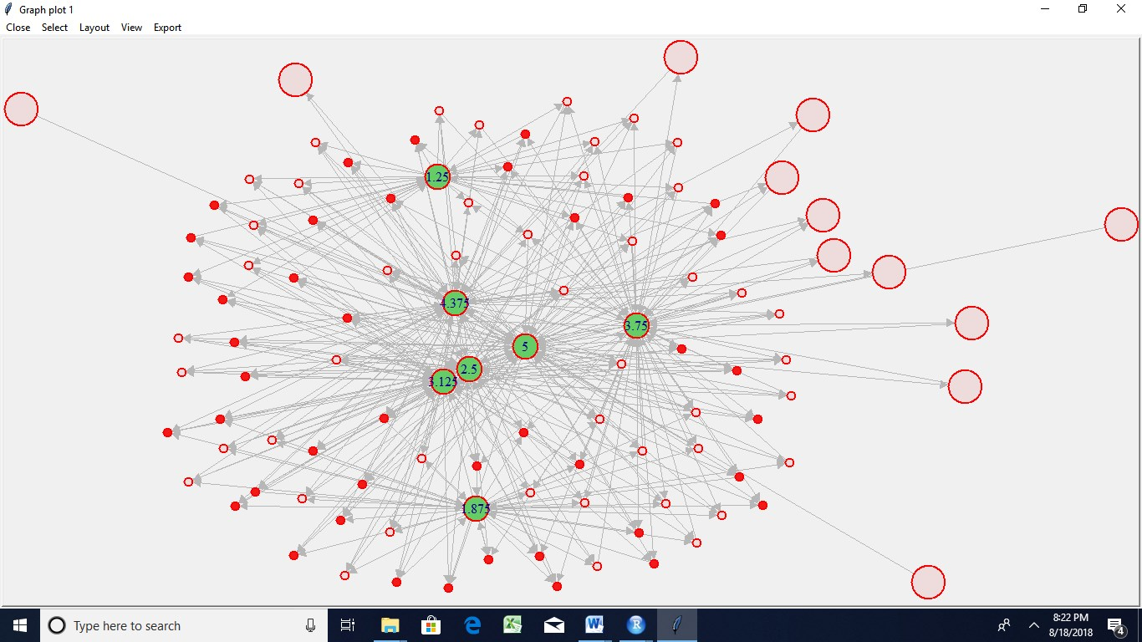

Random type

Circle

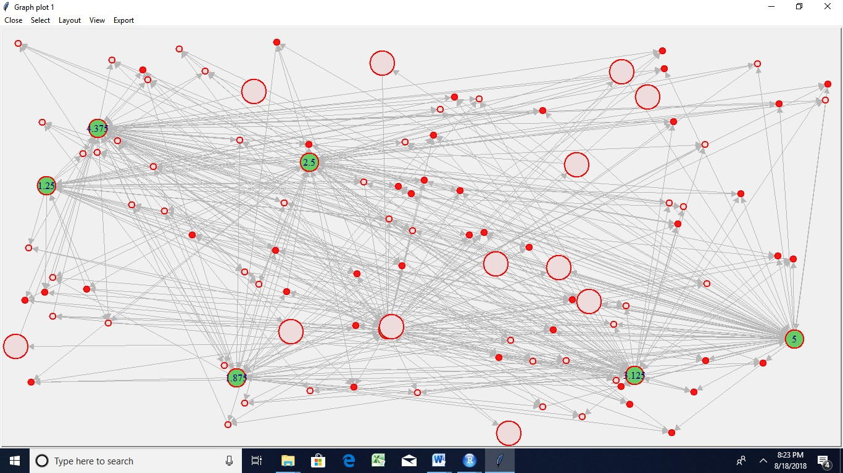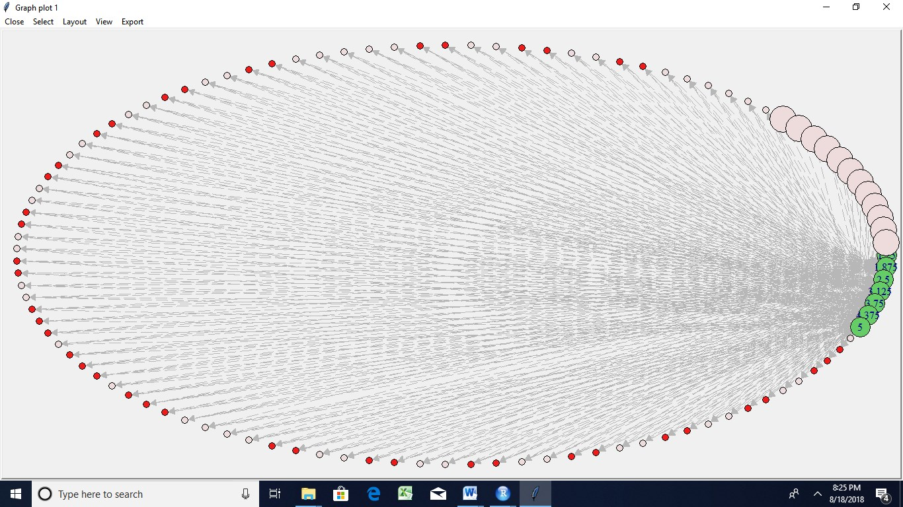

Kamada kawai

Reingold

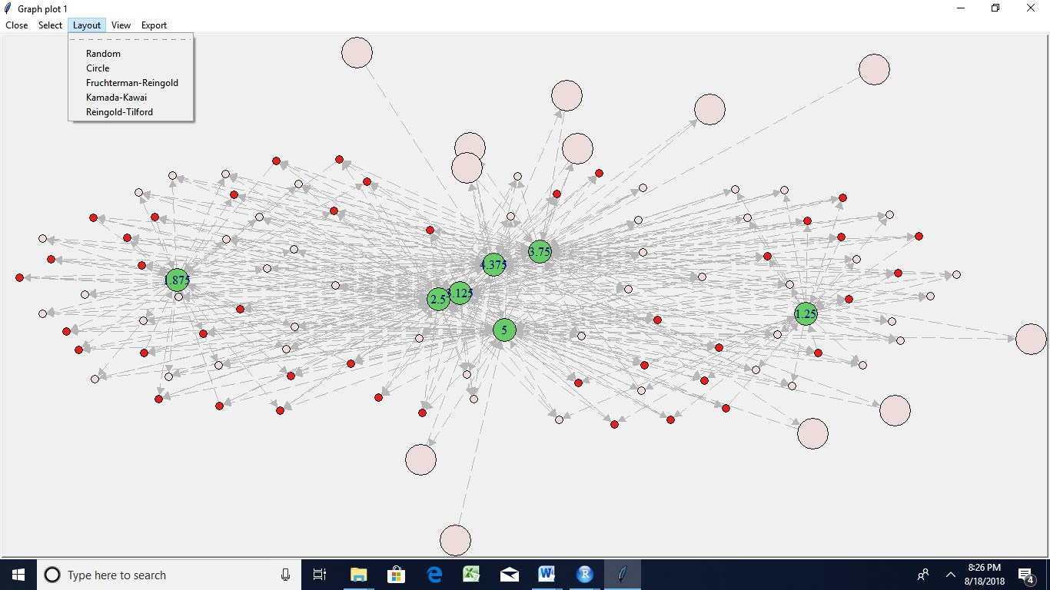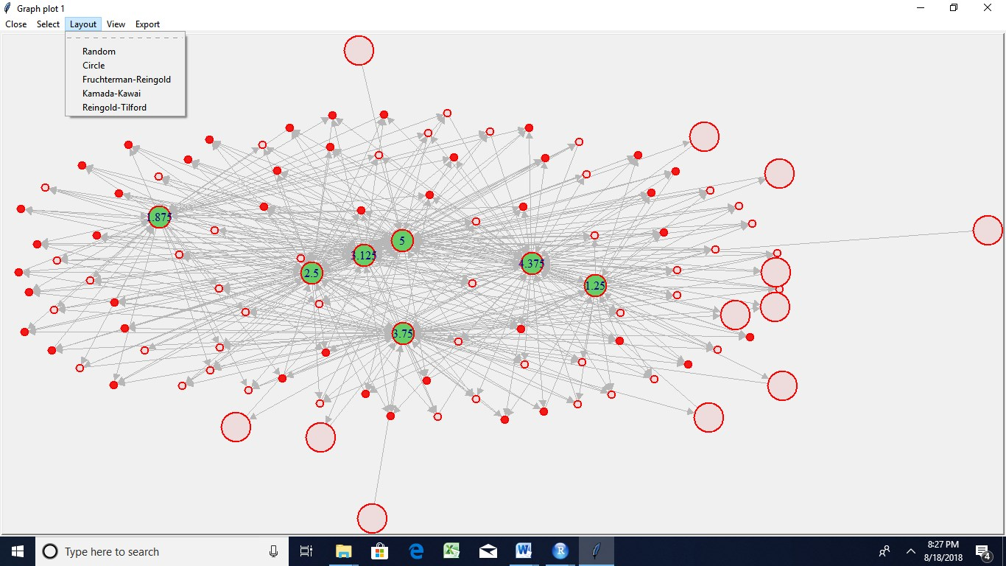

Session 21 Assignment 2

nd

additional

exercise

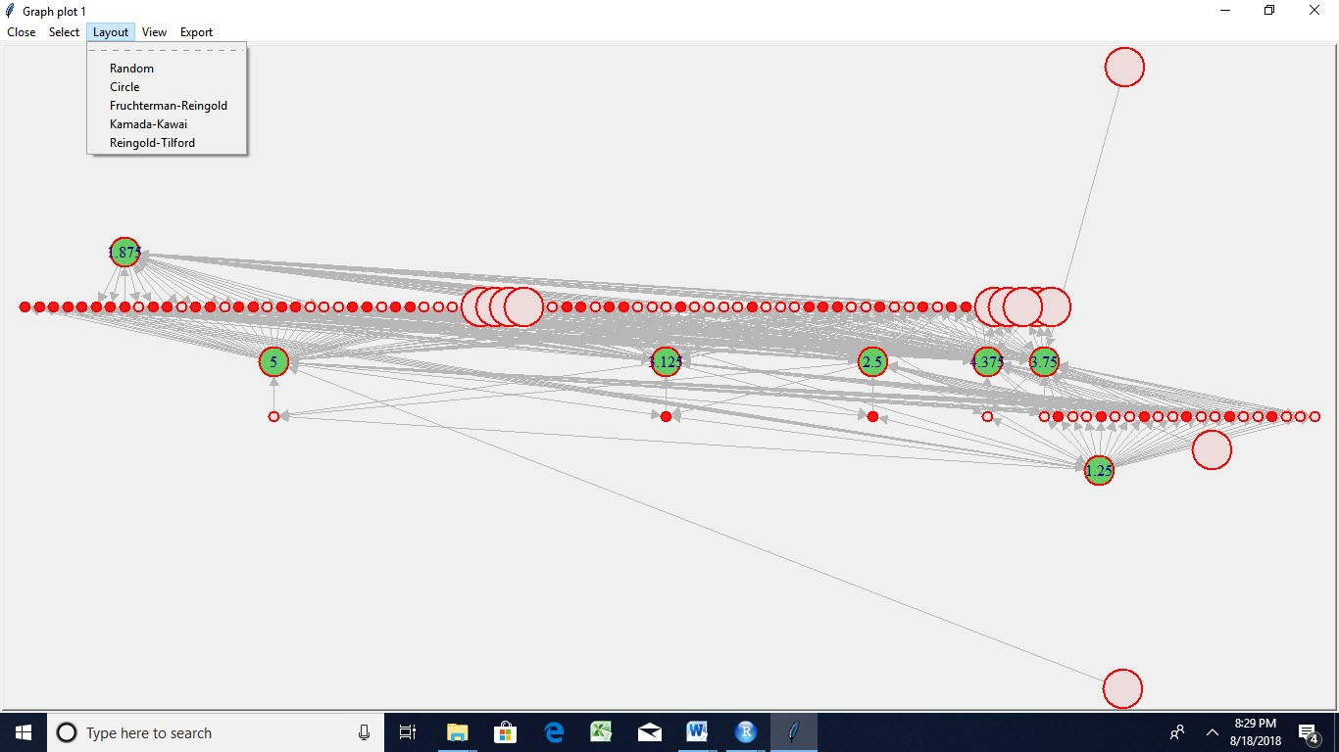

**session21_pci.R**

Seshan

Thu Aug 16 15:46:09 2018

|  |  |  |
| --- | --- | --- |
| **setwd**("C:/Users/Seshan/Desktop/sv R related/acadgild/assignments/session21") | |  |
| **library**(readr)  epi_r <- **read.csv**("C:/Users/Seshan/Desktop/sv R related/acadgild/assignments/ session21/epi_r.csv") **View**(epi_r) data<-epi_r  **View**(data)    a <- **aggregate**(data[,**-**1], by=**list**(data[,1]), paste, collapse=",") a**$**combined <- **apply**(a[,2**:ncol**(a)], 1, paste, collapse=",")  a**$**combined <- **gsub**(",NA","",a**$**combined) ## this column contains the totality of all ingredients for a cuisine    cuisines <- **as.data.frame**(**table**(data[,1])) ## Number of recipes for each cuis ine  freq <- **lapply**(**lapply**(**strsplit**(a**$**combined,","), table), as.data.frame) ## Fre quency of ingredients | |
| **names**(freq) <- a[,1] | (freq), **function**(i) { **colnames**(freq[[i]])[2] <- **names**  2] <- freq[[i]][,2]**/**cuisines[i,2] ## proportion (normali    ## this is a list of 26 elements, one for each cuisine **function**(...) **merge**(..., all=TRUE, by="Var1"), prop) final[,1]  <- 0 ## If ingredient missing in all recipes, proportion  proportion matrix  2, sd), decreasing=TRUE)  ## Selecting ingredients with maximum variation in frequency among cuisines a  ## Using standardized proportions for final analysis **subset**(final, select=**names**(**which**(s **>** 0.1))))    ## The following object is masked from 'package:stats':  trace="none", margins = **c**(6,11), col=**topo.colors**(7), key.title=NA, keysize=1.2, density.info="none") | |
| prop <- **lapply**(**seq_along** (freq)[i] freq[[i]][, zed frequency) freq[[i]]}) **names**(prop) <- a[,1] final <- **Reduce**( **row.names**(final) <- final <- final[,**-**1] final[**is.na**(final)] set to zero final <- **t**(final) ## s <- **sort**(**apply**(final,  nd  final_imp <- **scale**(  ## heatmap  **library**(gplots) ##  ## Attaching package: 'gplots'  ##  ## lowess  **heatmap.2**(final_imp, key=TRUE, |

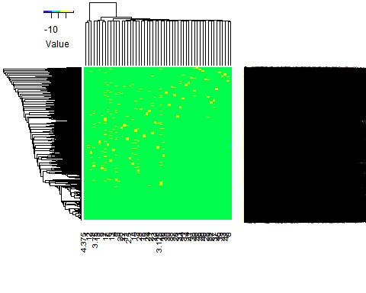

|  |  |
| --- | --- |
| ## PCA and biplot | final_imp)  TRUE, col=**c**("black","red"), cex=**c**(0.9,0.8),xlim=**c**(**-**2.5,2.5  "PC1, 39.7% explained variance", ylab="PC2, 24.5% explained variance" |
| p <- **princomp**( **biplot**(p,pc.biplot=  ), xlab=  ) |



  
  
  